Document ID: 03_05_10_1
Date Received: 2010-03-05 Date Revised: 2013-04-5 Date Accepted: 2013-04-6
Curriculum Topic Benchmarks: M1.3.9, M1.4.2, M8.3.9, S15.3.3, S3.4.3
Grade Level: High School [9-12]
Subject Keywords: star, parallax, motion, distance, velocity
Rating: moderate

Studies of a Population of Stars:
Distances and Motions

By: Stephen J Edberg, Jet Propulsion Laboratory, California Institute of Technology, 4800 Oak Grove Drive, M/S 183-301, Pasadena CA 91011
e-mail: Stephen.J.Edberg@jpl.nasa.gov

From: The PUMAS Collection http://pumas.nasa.gov
©2010 Jet Propulsion Laboratory, California Institute of Technology. ALL RIGHTS RESERVED.

Venture out under a clear night sky, in city or country, bright moon or dark moon, and you will see at least a few stars. Fortunately, the brightest stars visible offer a wide variety of characteristics that can be observed or computed easily. With this activity, students have the chance to see these bright stars and learn about their distances and motions.

While not obvious to the casual observer of the night sky, the stars, including the Sun, are in motion. Except for a small handful of stars, this motion requires careful measurements to detect. “Proper motion” is the term used to describe a star’s motion across the sky; “radial velocity” is the term used to describe a star’s motion along the line of sight “through” the sky’s “surface.” The motions measured by astronomers are due to the combined motions of the stars, and the Sun, as they orbit the center of our Milky Way galaxy. The differences in the stellar motions observed across the sky – fast and slow, grouped or random directions – are intriguing and demonstrate the complexity of the work necessary to interpret the results (Figure 1).

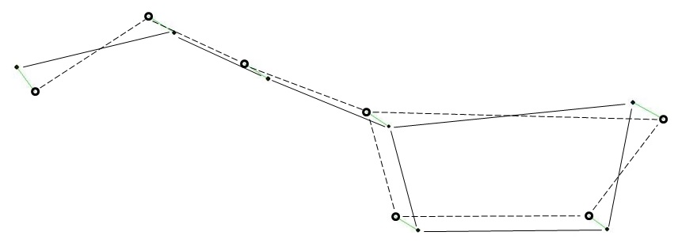
Fig. 1. The Big Dipper familiar to observers in 2000 C.E. (dots connected by solid lines) will be noticeably distorted by 72,000 C.E. (circles connected by dashed lines). Five of the stars originated together and are on parallel paths through space but two others have independent motions. This graphic is courtesy of Starry Nights® Pro Version 3, Imaginova® Corp.
The universe is rich with interesting phenomena. Stars, alone, offer many opportunities for investigation. The results of this activity stand alone or they may be combined with results from other “Studies of a Population of Stars” activities for more insights (PUMAS Examples 03_05_10_2 “Distances and Motions,” and 03_05_10_3 “How Bright Are the Stars, Really?”).

OBJECTIVE: Make night sky observations and use available data and simple calculations to correlate these observations with the characteristics of stars and their motions. In this activity, the distances of bright stars are calculated and their motions, in the plane of the sky and in three dimensions, are illuminated.

APPARATUS:

- Scientific calculator or computer spreadsheet for each student, or for small groups of students to share
- Data tables (Appendix 1) supplied with this example
- Star charts (Appendix 2) supplied with this example

ACTIVITIES:

Duplicate and distribute star charts (Appendix 2) and the table of star information (Appendix 1) to the students. One particular star chart from the set provided should be chosen based on the time of year and your hemisphere. The activity can be limited to stars visible in the evening sky during the chosen season. Specific stellar data tables for the season can be cut/pasted from the full set included with this activity in Appendix 1, based on the calendar-organized table in the DISCUSSION section below. Alternatively, the full set of stars may be analyzed even though not all will be visible at any particular time of year. Measurement units in the activities below are in [brackets]. An explanation of the terminology in the activities is found in the DISCUSSION section below. The phrases in bold describe the instructional activity.

- Students should spend an evening outdoors and observe some of the stars they will be analyzing with the data provided in Appendix 1. They should first relate the stars appearing within their star chart (pertaining to their time of year and hemisphere) to the stars listed in the data table (Appendix 1), to identify which subset of those stars will be visible in their nighttime sky (further help in DISCUSSION section). For this subset of stars, they should be encouraged to find them in the night sky, and make note of their observed brightnesses, color differences (subtle but visible) and the distribution of these stars in the sky – are they found in all directions or more common in some preferred direction(s)?

- Calculate the distances to stars. When an object is inaccessible – a mountain summit or a distant star – known distances can be combined with measured angles to determine a distance or altitude. The method relies on parallax, the way an object appears to move, relative to a more distant background, when viewed from different positions. See DISCUSSION below and Edberg (2005) for a PUMAS example (04_28_05_1) explaining parallax.

The parallax (PLX) in milliarcseconds (thousandths of an angular second of arc, [mas]) can be converted from an angular measure to a physical distance (D) easily. Multiply the parallax in [mas] by 1000 and then take the reciprocal:

D = 1/(PLX ∙ 1000) [parsecs, pc] (1)

A parsec (parallax-second of arc) is the distance at which the angle subtended by the radius of Earth’s orbit around the Sun, 1 astronomical unit (AU), is 1 arc second. Most students won’t have a feel for distances in parsecs so convert it to light years [ly], the distance light travels in one year’s time. A parsec is 3.261631 light years and a light year is 9.460536x10¹⁵ meters (Bishop, 2007):

1 [pc] = 3.262 [ly] (2)

- Using the resolved directions of the stars’ proper motions (north-south and east-west, PM_{N-S} and PM_{E-W}, respectively) students should plot vectors on graph paper. Vector addition of the components show the stars’ total proper motions across the sky. The length of the vector sum should equal the magnitude of the proper motion, calculated using:

Overall Proper Motion [mas/yr] = √{(PM_{N-S} [mas/yr])² + (PM_{E-W} [mas/yr])²} (3)

- Of greater interest are the three dimensional space velocities of the stars. By converting the angular proper motions to physical velocities and combining those with the (physical) radial velocity, the space motion can be computed. Three dimensional parallelepiped models of individual stars’ motions can be made with pipe cleaners, scaling km/s to mm of pipe cleaner.
First, the angular rate, mas/yr can be converted to radians/yr:

[rad/yr] = {[mas/yr]/1000}/206265 (4)

where 206265 is the number of seconds of arc in a radian and 1000 converts [mas] to seconds of arc. Using the small angle approximation and the distance computed with equation (2), the proper motion is

PM [pc/yr] = PM[rad/yr] ∙ D [pc] (5)

which is still not easy to grasp. Use conversion factors (Bishop, 2007) of 1 parsec = 3.086x10¹³ km and 1 yr = 3.156x10⁷ seconds to calculate the proper motions in km/s.
The space velocity is the square root of the sum of the squares of the proper motions and radial velocity:

Space Velocity [km/s] = √{(PM_{N-S}[km/s])² + (PM_{E-W}[km/s]² + (RV[km/s])²} (6)

- Plot proper motion vs. distance.
The plot of proper motion vs. distance can be compared to the view of the motion of cars on a highway, viewed from the side of a rode (perpendicular to the cars’ motions). If all the cars are moving at the same physical speed, the cars in the closest lane will appear to be moving faster in angular units of [degrees/second] because they are closer to the observer than cars in more distant lanes.
Stars have their individual peculiar motions (except for some prominent clusters, like the Pleiades, and other groups, like some stars in the Big Dipper, which are traveling together) but the principle still generally holds: closer stars have higher proper motions. The proper motions charts in Appendix 3 suggest that some of the bright stars being studied are close, while others are distant. Additional study of these charts shows that there are a number of faint stars that have much greater proper motions than the bright stars studied in this activity.
Careful study of many proper motions across the sky was used, as early as the 18th century by William Herschel (discoverer of Uranus), to determine the direction of the Sun’s motion through the universe. (At that time, astronomers didn’t know the solar system was a part of the Milky Way galaxy, itself only a small part of the universe. In fact, they did not know the universe contained myriad giant groupings of stars we now call “galaxies.”)
The plot of space velocity vs. distance tells a different story. Is there a correlation between distance and physical velocity? Advanced Extension: With all the bright stars in the tables of Appendix 1, can a “flow” be identified based on proper motion directions or radial velocity? This advanced study requires geometric transformation of each vector component of the stars’ space velocities to a common origin. Such studies typically use hundreds to thousands of stars.

THE UNDERLYING PRINCIPLES:

Fundamental questions about stars in the sky include:

Are they moving? In what directions?
How far away are they?

These questions can be answered using the data table for each star in the collection.

Most people notice the Moon’s nightly motion against background stars and some notice the motion of planets over a few days or weeks. The motions of stars are much slower and require careful measurements. Still, the stars are actually moving at speeds much greater than the orbital speeds of the Moon and planets. It is their great distances from us that mask their rapid motion. Over spans of thousands of years, familiar constellations will be distorted by the proper motions of their stars (Figure 1).

A star’s motion on the plane of the sky is called proper motion and it is usually specified in angular units based on a system of what are called “equatorial” coordinates, typically milli-arc seconds per year (that is, thousandths of one second of arc per year; there are 3600 seconds of arc in one degree of arc). One can think of equatorial coordinates as analogous to longitude and latitude on Earth, but projected onto the sky as “right ascension” and “declination,” respectively. Proper motion is specified east-west and north-south.

Proper motion is an indication of the orbital motion of stars, including the Sun, around the center of the Milky Way galaxy. Just as the planets orbit the Sun, the Sun and stars orbit the core of the Milky Way. When we make measurements of the proper motions of near and distant stars in all directions around the Sun we can observe a “flow” of stars. The stars’ motions reflect their own orbits around the Milky Way, their distances from the Sun, and the effect of the Sun’s motion on our view of their motions.

(Think about how cars moving along the lanes of a freeway appear. Standing on the side of the road the closer cars and trucks in the slow lane seem to be moving faster than those in the fast lane. It is your distance from the fast lane that can make the faster cars appear to move more slowly than the closer cars and trucks. Changing your perspective, as you drive down the freeway in a middle lane, some cars pass you and you pass some cars, and their apparent speeds also vary depending on how far away they are from you.)

Stellar motion through the plane of the sky, towards or away from the observer, is called radial velocity and is measured in km/s. It can be measured with a telescope+spectrometer, which show a red shift or blue shift in the starlight depending on whether the star is receding or approaching, respectively (see: Edberg 2005, PUMAS example 04_28_05_1, “What the Doppler Effect Tells Us About Distant Stars and Planets”).

DISCUSSION:

The stars included in this activity are among the brightest in the sky and are easily visible with the Moon up and in light polluted cities (but not where skyscrapers or trees block the sky!). Use the orientation “rose” on each star chart to help with orienting the charts at night. The stellar data presented here were downloaded from the SIMBAD Astronomical Database, http://simbad.u-strasbg.fr/simbad/ .

The following sets of stars can be used, and viewed, annually from either the northern or southern hemisphere, with considerable geographic and seasonal overlap. After choosing the time of year for observing, star selection should be based on any familiar constellations first and then biased toward the hemisphere in which you reside. Stars with positive declinations will be most easily visible from the northern hemisphere; negative declinations are better seen from the southern hemisphere. (Declination is the celestial equivalent of latitude on Earth; examine the equatorial coordinates in the tables in Appendix 1, which are explained below.) Some stars at higher positive (north) or negative (south) declinations will not be visible from the opposing hemisphere and others will barely skim the horizon. Stick to lower declinations when possible.

The quarters of the year used in the table are based on the assumption that the stars will be observed during evening hours. For viewing, there is considerable overlap of star availability across the quarterly boundaries (as with hemispheres) and they can often be seen for many months before the quarter given if the observer stays up later in the night or looks before dawn. Use a star chart, planisphere (“star wheel”), or planetarium software to determine which stars can be used to match the timing of your syllabus.

The tables of star data in Appendix 1 are organized alphabetically by CONSTELLATION and then by Star Name. The tables contain a variety of information that can be extracted and used to compare and contrast these bright stars. Learning will be improved if students put together their own naked eye observations of stars with the data supplied in the tables. The space motions of many stars can be determined. Figure 2 illustrates a table entry and the text below describes the table entries. A glossary/summary table in the same format as the tables of stars is the first in Appendix 1.

Bright Evening Stars
CONSTELLATION-Hemisphere; Star Name
Jan.-Feb.-Mar. | Apr.-May-June | July-Aug.-Sep. | Oct.-Nov.-Dec.
AURIGA – N  Capella | AURIGA – N  Capella | AQUILA – N  Altair | AQUILA – N  Altair
CANIS MAJOR – S  Sirius | BOOTES – N  Arcturus | BOOTES – N  Arcturus | AURIGA – N  Capella
CANIS MINOR – N  Procyon | CANIS MINOR – N  Procyon | CENTAURUS – S  Alpha Centauri | CYGNUS – N  Deneb
CARINA – S  Canopus | CARINA – S  Canopus | CENTAURUS – S  Beta Centauri | ERIDANUS – S  Achernar
ERIDANUS – S  Achernar | CENTAURUS – S  Alpha Centauri | CRUX – S  Acrux | LYRA – N  Vega
GEMINI – N  Castor | CENTAURUS – S  Beta Centauri | CRUX – S  Mimosa | PISCIS AUSTRINUS – S  Fomalhaut
GEMINI – N  Pollux | CRUX – S  Acrux | CRUX – S  Gacrux | TAURUS – N  Aldebaran
ORION – Equator  Betelgeuse | CRUX – S  Mimosa | CYGNUS – N  Deneb
ORION – Equator  Rigel | CRUX – S  Gacrux | LYRA – N  Vega
TAURUS – N  Aldebaran | GEMINI – N  Castor | PISCIS AUSTRINUS – S  Fomalhaut
 | GEMINI – N  Pollux | SCORPIUS – S  Antares
LEO – N
Regulus
VIRGO – Equator
Spica

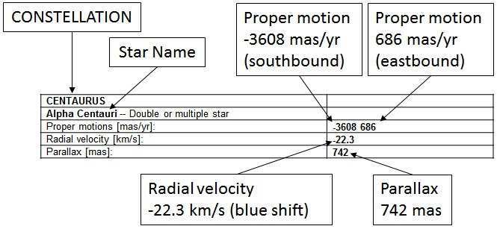

Fig. 2. This is an example of the entries made for stars in Appendix 1.

Proper motions (PMs) are the measured (when possible) motions of stars on the plane of the sky, across the line of sight. Celestial southbound and celestial westbound (look at the map roses on the charts in Appendix 2) are negative. Several stars’ PMs are so low that they are not presented on the Proper Motion charts. This is not surprising considering their distances or true motions (see below).

Radial velocity is measured along the line of sight. Positive (+) is away from the observer, yielding a Doppler red shift. Negative indicates approach and produces a blue shift.

The combination of proper motion and radial velocity gives the space velocity in three dimensions. Actually computing that motion (square root of the sum of the squares of the velocities in km/s) requires knowledge of the distance, which can be computed using the parallax.

Parallax is one-half the angular shift in position of a star viewed, against a background of more distant stars, from diametrically opposite locations of the Earth in its orbit around the Sun, e.g., the summer and the winter locations. (To see this, hold up a finger at arm’s length and alternately close your eyes. Your finger seems to move against objects in the background, by twice the parallax angle [since your eyes are separated by twice their separation from your nose, analogous to the separation between the opposite orbital locations of the Earth in its solar orbit]. Visit http://pumas.nasa.gov for a PUMAS example on parallax [Edberg, 2005; 04_28_05_1].)

To convert parallax in milliarcseconds [mas] to distance, D, first multiply [mas] by 1000 to get the parallax in seconds of arc [arc seconds, as]. The distance in the units of parsecs [pc, parallax seconds] is the reciprocal of the parallax in [as]:

D [pc] = 1/(parallax [as]). (8)

A parsec is 3.261631 light years ([ly], the distance light travels in one year) and a light year is 9.460536x10¹⁵ m (Bishop, 2007).

Simple trigonometry can now be used to convert the proper motions in [mas/yr] to (fractions of) [light years/year], and then to [m/s] or [km/s].

REFERENCES:

Bishop, R., 2007, “Some Astronomical and Physical Data” in Observer’s Handbook 2008, P. Kelly, ed., Royal Astronomical Society of Canada, Toronto.

Edberg, S. J., 2005, “When A Ruler Is Too Short,” Practical Uses of Math and Science, http://pumas.jpl.nasa.gov , accepted 2005 August 25.

FOR MORE INFORMATION:

Kelly, P., 2007, Observer’s Handbook 2008, Toronto: Royal Astronomical Society of Canada.

Starry Nights Pro. (Ver. 3, 1997 was used; Ver. 6 is now available) [Computer software]. New York, New York: Imaginova.

TheSky6 Professional Edition Version 6 for Windows. (2004). [Computer software]. Golden, Colorado: Software Bisque.

ACKNOWLEDGMENTS:

I am grateful to Dr. Larry Lebofsky, an anonymous reviewer, and PUMAS Editor Dr. Ralph Kahn for many fine edits and advice that improved the clarity and completeness of the discussions in this activity.

This research has made use of the SIMBAD database, operated at CDS, Strasbourg, France, http://simbad.u-strasbg.fr/simbad/.

The star and constellation charts were generated by TheSky6 © Software Bisque, Inc. All rights reserved. www.bisque.com.

The proper motion star chart graphics are courtesy of Starry Nights® Pro Version 3, Imaginova® Corp.

This publication was prepared by the Jet Propulsion Laboratory, California Institute of Technology, under a contract with the National Aeronautics and Space Administration.

Reference herein to any specific commercial product, process, or service by trade name, trademark, manufacturer, or otherwise, does not constitute or imply its endorsement by the United States Government or the Jet Propulsion Laboratory, California Institute of Technology.
APPENDIX 1: Star Tables
Key to the star information tables below. The tables are alphabetized by constellation. Star data are from the SIMBAD database, operated at CDS, Strasbourg, France, http://simbad.u-strasbg.fr/simbad/. Star proper motions are obtained from very precise telescopic observations of star locations on the celestial sphere over time. Similarly, parallax values are typically determined by very precisely measuring star locations relative to more distant stars (see Edberg 2005, PUMAS example 06_09_05_1, “When a Ruler is Too Short”). Radial velocities are derived from the Doppler shifts of stellar spectral lines (see Edberg 2005, PUMAS example 04_28_05_1, “What the Doppler Effect Tells Us About Distant Stars and Planets”).

CONSTELLATION name
Star name – Brief description or other designator
Proper motions [milliarcseconds/yr, mas/yr]: | Motion on plane of the sky with sign indicating celestial direction: N-S (south is negative) is listed first followed by E-W (west is negative).
Radial velocity [km/s]; negative sign indicates approach = blueshift. | [km/s]
Parallax [milliarcseconds, mas] is one-half the angular change in position of a star seen against a background of more distant stars across the diameter of Earth’s orbit around the Sun. | Can be converted to distance
AQUILA
Altair -- Variable Star of delta Sct type
Proper motions [mas/yr]: | 536.87 385.57
Radial velocity [km/s]: | -26.1
Parallax [mas]: | Not available
AURIGA
Capella -- Variable of RS CVn type
Proper motions [mas/yr]: | 75.52 -427.11
Radial velocity [km/s]: | 30.2
Parallax [mas]: | 77.29
BOOTES
Arcturus -- Variable Star
Proper motions [mas/yr]: | -1093.43 -1999.43
Radial velocity [km/s]: | -5.2
Parallax [mas]: | 88.85
CANIS MINOR
Procyon -- Spectroscopic binary
Proper motions [mas/yr]: | -716.58 -1034.6
Radial velocity [km/s]: | -3.2
Parallax [mas]: | 284.56
CANIS MAJOR
Sirius -- Spectroscopic binary
Proper motions [mas/yr]: | -546.05 -1223.14
Radial velocity [km/s]: | -7.6
Parallax [mas]: | 379.21
CARINA
Canopus -- Star
Proper motions [mas/yr]: | 19.99 23.67
Radial velocity [km/s]: | 20.5
Parallax [mas]: | 10.43
CENTARUS
Alpha Centauri -- Double or multiple star
Proper motions [mas/yr]: | -3608 686
Radial velocity [km/s]: | -22.3
Parallax [mas]: | 742
CENTARUS
Beta Centauri -- Variable Star of beta Cep type
Proper motions [mas/yr]: | -33.96 -25.06
Radial velocity [km/s]: | 5.9
Parallax [mas]: | 6.21
CRUX
Acrux -- Spectroscopic binary
Proper motions [mas/yr]: | -35.3 -12
Radial velocity [km/s]: | -11.2
Parallax [mas]: | Not available
CRUX
Mimosa = Beta Cru -- Variable Star of beta Cep type
Proper motions [mas/yr]: | -48.24 -12.82
Radial velocity [km/s]: | 15.6
Parallax [mas]: | 9.25
CRUX
Gamma Crucis -- Variable Star
Proper motions [mas/yr]: | 27.94 -264.33
Radial velocity [km/s]: | 21.4
Parallax [mas]: | 37.09
CYGNUS
Deneb -- Alpha Cyg -- Variable Star
Proper motions [mas/yr]: | 1.56 1.55
Radial velocity [km/s]: | -4.5
Parallax [mas]: | 1.01

ERIDANUS
Achernar -- Be Star
Proper motions [mas/yr]: | 88.02 -40.08
Radial velocity [km/s]: | 16
Parallax [mas]: | 22.68
GEMINI
Castor -- LTT 12038 -- High proper-motion Star
Proper motions [mas/yr]: | -354.51
Radial velocity / Redshift / cz: | Not available
Parallax [mas]: | 63.27
GEMINI
Pollux -- Variable Star
Proper motions [mas/yr]: | -625.69 -45.96
Radial velocity [km/s]: | 3.3
Parallax [mas]: | 96.74
LEO
Regulus -- Variable Star
Proper motions [mas/yr]: | -249.40 4.91
Radial velocity [km/s]: | 5.9
Parallax [mas]: | 42.09
LYRA
Vega -- Alpha Lyr -- Variable Star
Proper motions [mas/yr]: | 201.03 287.47
Radial velocity [km/s]: | -13.9
Parallax [mas]: | 128.93
ORION
Betelgeuse --V* alf Ori -- Semi-regular pulsating Star
Proper motions [mas/yr]: | 27.33 10.86
Radial velocity [km/s]: | 21.0
Parallax [mas]: | 7.63
ORION
Rigel -- Emission-line Star
Proper motions [mas/yr]: | 1.87 -0.56
Radial velocity [km/s]: | 20.7
Parallax [mas]: | 4.22
PISCIS AUSTRINUS
Fomalhaut -- Variable Star
Proper motions [mas/yr]: | 329.22 -164.21
Radial velocity [km/s]: | 6.5
Parallax [mas]: | 130.08
SCORPIUS
Antares -- Alpha Sco -- Semi-regular pulsating Star
Proper motions [mas/yr]: | -10.16 -23.21
Radial velocity [km/s]: | -3.4
Parallax [mas]: | 5.40
TAURUS
Aldebaran -- Alpha Tau -- Variable Star
Proper motions [mas/yr]: | 62.78 -189.35
Radial velocity [km/s]: | 54.3
Parallax [mas]: | 50.09
VIRGO
Spica -- 67 Vir -- Variable Star of beta Cep type
Proper motions [mas/yr]: | -42.50 -31.73
Radial velocity [km/s]: | 1.0
Parallax [mas]: | 12.44

APPENDIX 2: Star and Constellation Charts
The following collection of charts is designed to make it easy to find and identify bright stars. In the charts, prominent and/or well-known stars or groups of stars, constellations, or super-constellations are used to point to other prominent stars. If desired, once a prominent star is found, other charts can be used to identify other stars in a constellation until the full constellation is recognized.
These charts are useful over large areas of Earth’s northern and southern hemispheres. They place a significant fraction of a celestial hemisphere on a small, flat piece of paper; sometimes stars or constellations will be below the horizon or blocked by local landmarks. Use separations between recognized stars (especially those paired) to make “pointers” to gauge the distance to the desired target star. In the northern hemisphere, April-June, the BIG DIPPER asterism (part of the constellation URSA MAJOR) visible high in the north is particularly good for learning the sky. ORION is good from November-January in the southern hemisphere and January-March in the northern hemisphere. Though the charts are labeled to indicate a hemisphere, many of the stars will be visible from the opposing hemisphere, depending on your latitude.
As a general rule, facing south is best, but some neck-craning (and/or facing a different direction and rotating the chart) will be necessary to go from the starting point to the target stars at the ends of the arrows. The font convention for the charts is that CONSTELLATIONS are fully capitalized and Star Names are larger and first-letter capitalized. Celestial North and West refer to the direction to those points on the horizon as seen on the sky. (In other words, east and west on the sky and on the charts are reversed compared to maps of features on Earth.) Most important: Choose a familiar group of stars, recognizable on a chart, and “star hop” from there.
At night, some observers find it is easier to use printed star charts with black stars on a white background rather than white stars on a black background. Black on white saves copier toner as well. The charts can be copied from this document and easily reversed with your image viewing and manipulation software if desired.

These star charts were generated by TheSky6 © Software Bisque, Inc. All rights reserved. www.bisque.com.

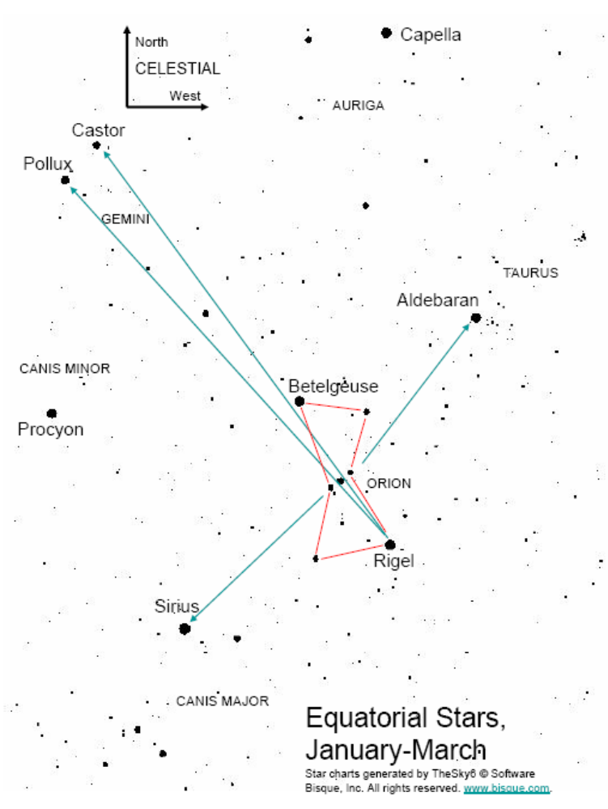

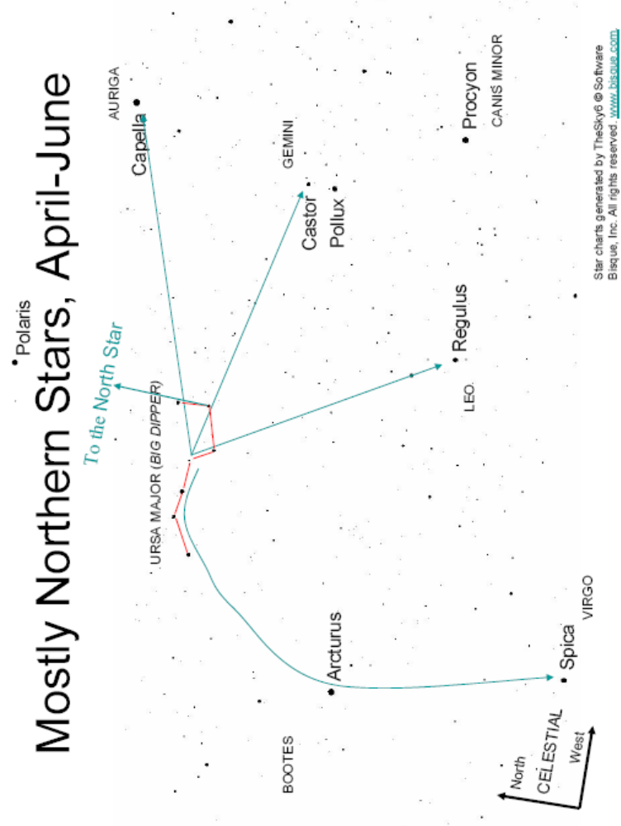

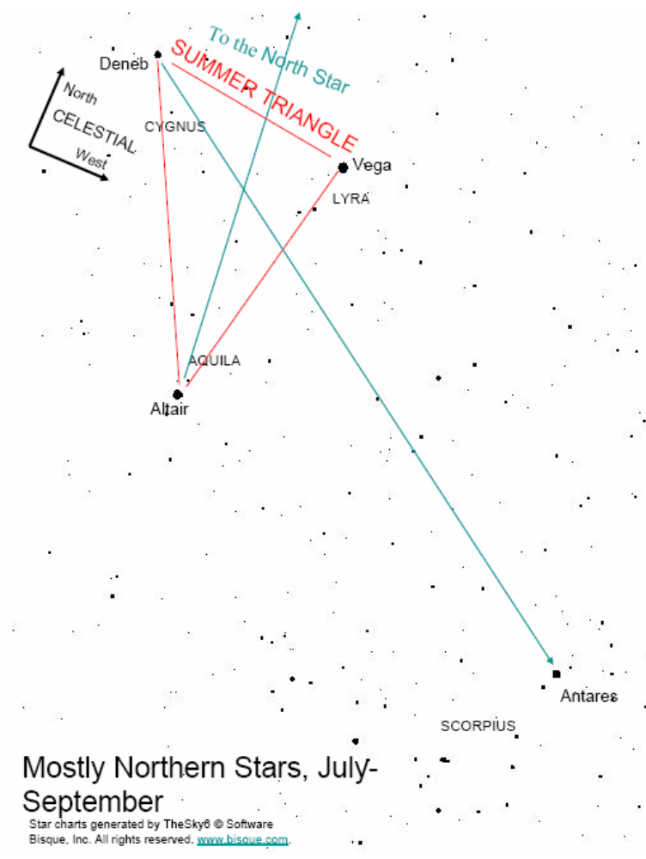

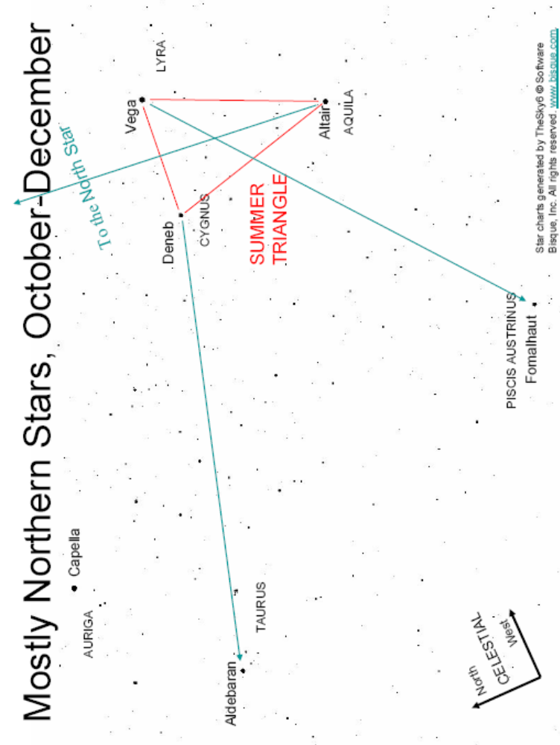

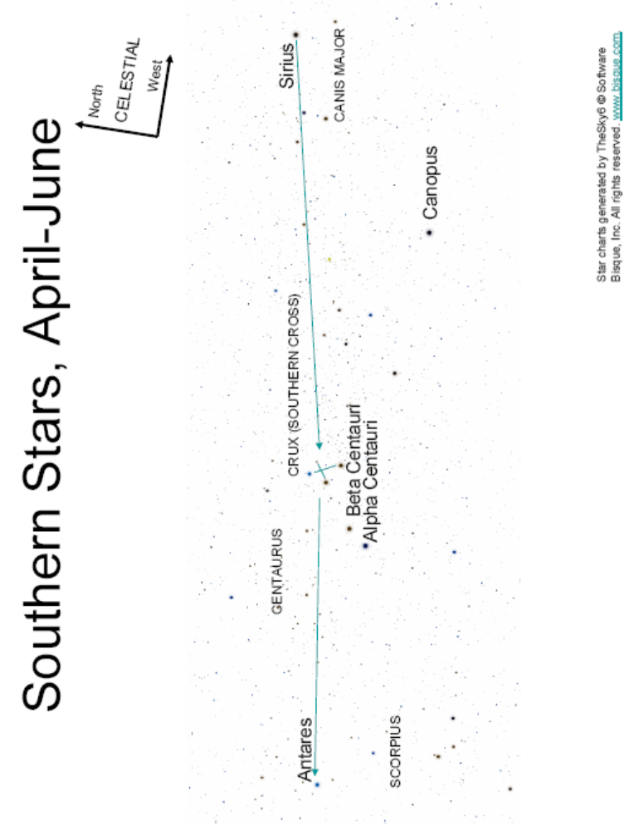

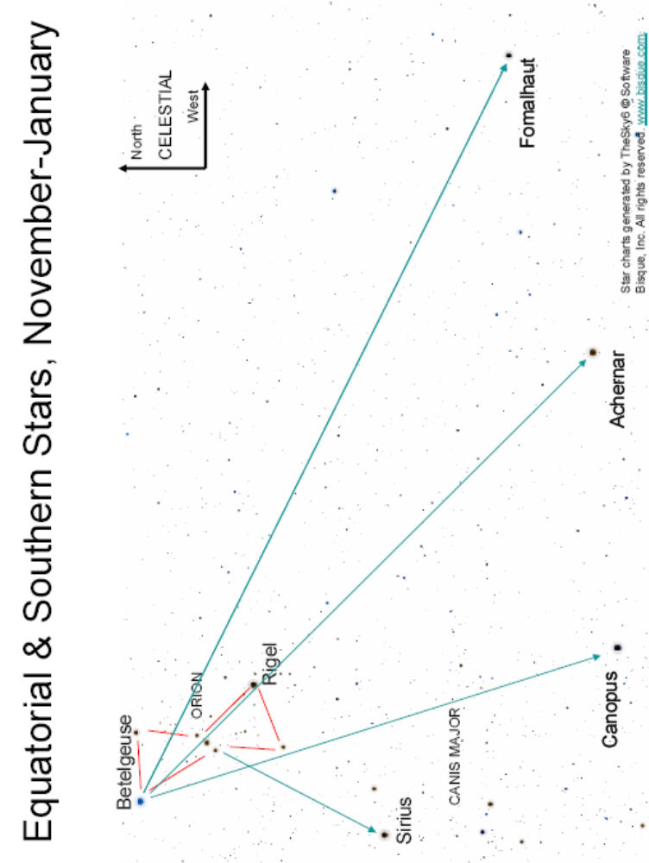
Appendix 3: Proper Motion Charts
The following collection of charts shows the proper motions, i.e., the motions on the plane of the sky of naked-eye stars. They are divided among four quarters of the year and both celestial hemispheres. They match the orientation and scale of the star and constellation finder charts (Appendix 2). Many of the charts overlap with portions of others in the set. Only Star Names are shown. Celestial North and West refer to the direction to those points on the horizon as seen on the sky. Note that the compass rose will change orientation across the chart since a large area of the curved sky is being reproduced on flat paper.
In these charts, only the prominent stars are called out. The call-outs of named stars are in similar positions with respect to the stars on the finder charts and on the proper motion charts. Both charts can be used together to locate stars on the proper motion charts when necessary.
Proper motions are indicated on the charts with line segments. The length of the line is an indication of the speed of the star across the sky. Its orientation shows the direction of overall motion. The lengths of the stars’ line segments correspond to about 70,000 years of proper motion. (The lengths of the line segments are different on different charts because the charts’ scales differ depending on how large an area of the sky is displayed.)
The proper motions indicated are not limited to the brightest stars. The pattern of line segments comes from both the stars discussed in this activity and from numerous other stars visible to the naked eye on a dark, clear night. Looking at the charts, one’s eyes will be drawn to the named stars and to the longest lines. Very often these are not paired together, hinting at discoveries to be made from the companion activity Studies of a Population of Stars: How Bright Are the Stars, Really?
These graphics are courtesy of Starry Nights® Pro Version 3, Imaginova® Corp.

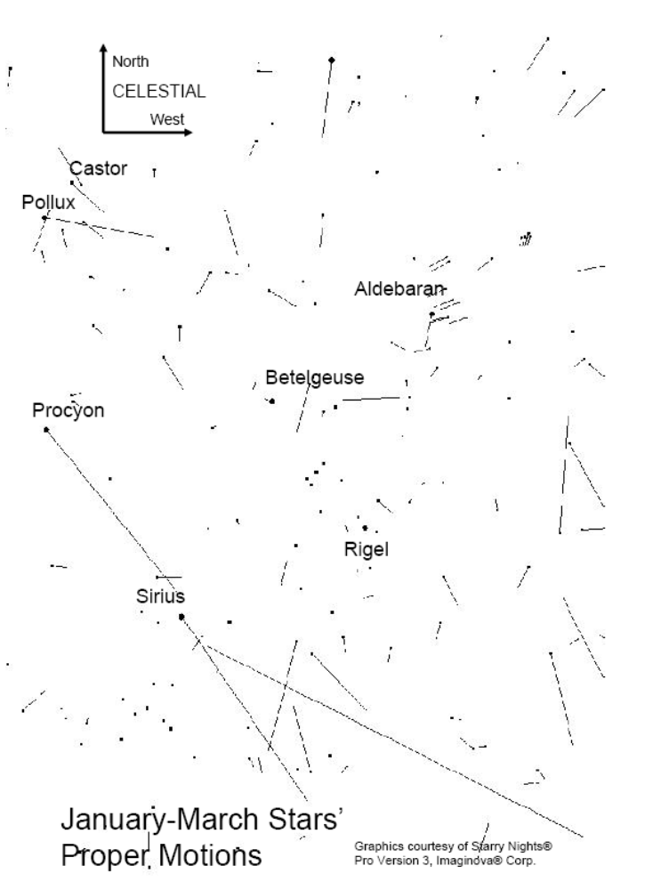

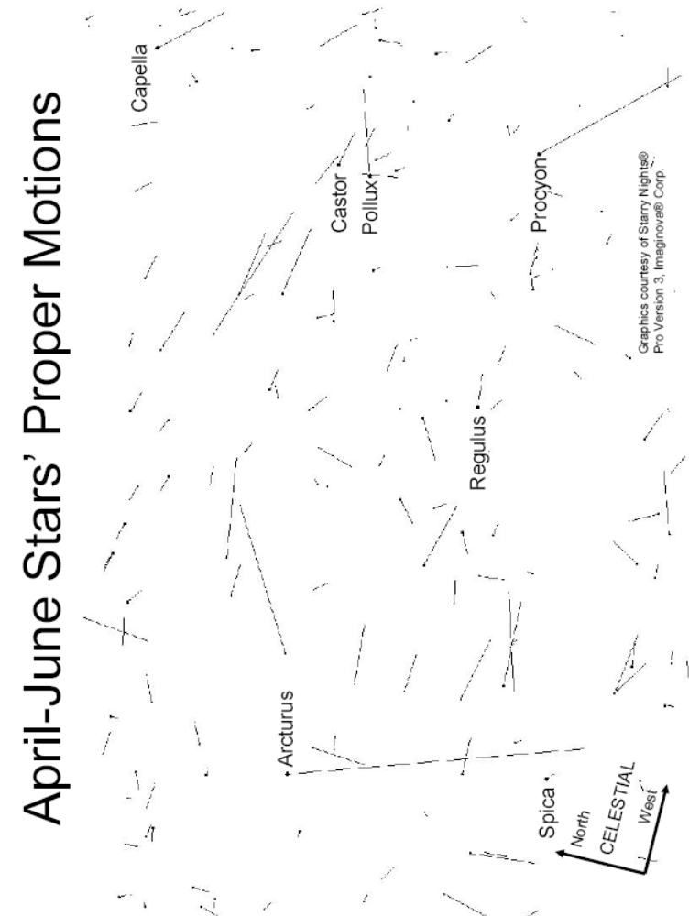

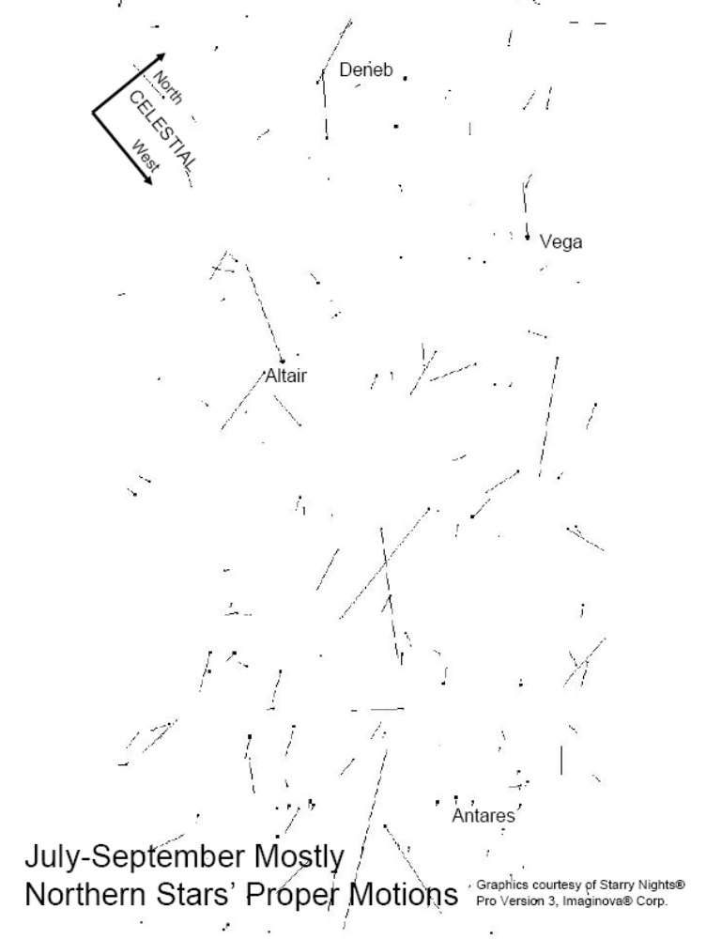

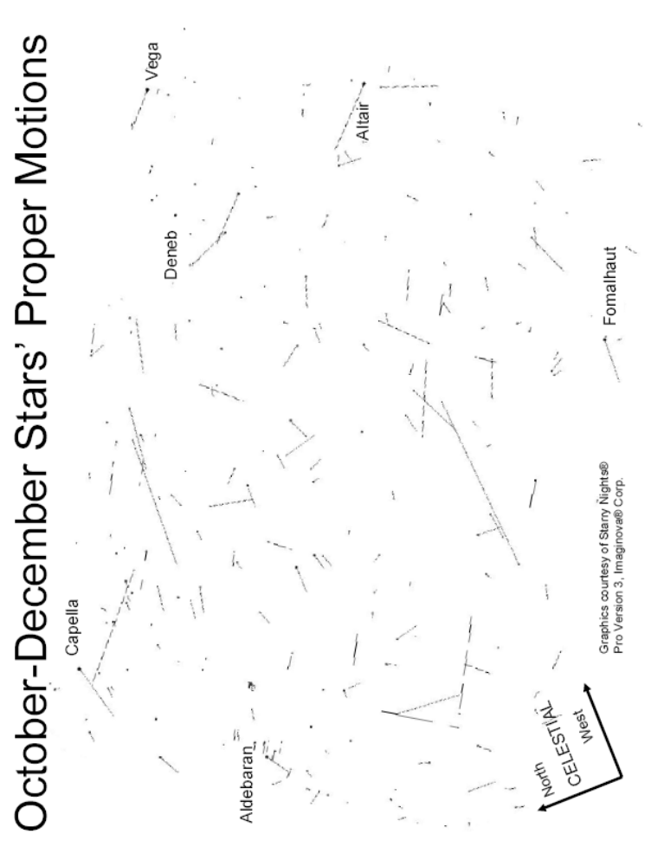

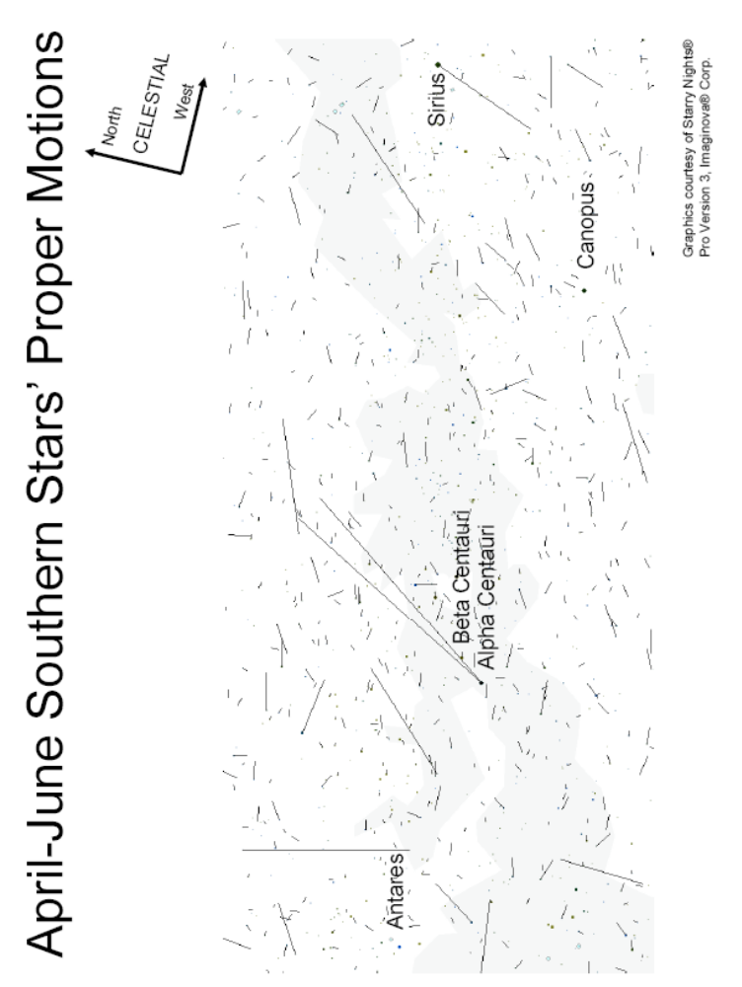



More advanced students may ask why trigonometric equations aren’t being used for these calculations, and some may notice that spherical trigonometry is really applicable. The answers are that for the tiny angles being discussed, the small angle approximation is applicable and treating the calculations as plane geometry will not reduce accuracy in any meaningful way for this activity.
Note that the modifier “celestial” in the text above and on the star charts indicates a compass direction defined by the horizon’s direction, not a table-top map direction. In other words, east and west are reversed in the sky compared to printed maps. (1) An observer facing due south in the northern or southern hemisphere with a standard map of the world right side up on a table in front of the observer would see west on the left side of the map and east on the right side of the map. The observer describing objects in the sky would say that objects to the observer’s left are to the east and objects to the right are to the west. (2) An observer facing due north in the northern or southern hemisphere with a standard map of the world right side up on a table in front of the observer would see west on the left side of the map and east on the right side of the map (no difference). This observer describing objects in the sky would say that objects to the observer’s left are to the west and objects to the right are to the east (different from south-facing observer). (3) When in doubt, remember that objects are always rising in the east and always setting in the west. The apparent rotation of the sky is always from east to west.
Note that the modifier “celestial” in the text and on the star charts indicates a compass direction defined by the horizon’s direction, not a table-top map direction. In other words, east and west are reversed in the sky compared to printed maps. (1) An observer facing due south in the northern or southern hemisphere with a standard map of the world right side up on a table in front of the observer would see west on the left side of the map and east on the right side of the map. The observer describing objects in the sky would say that objects to the observer’s left are to the east and objects to the right are to the west. (2) An observer facing due north in the northern or southern hemisphere with a standard map of the world right side up on a table in front of the observer would see west on the left side of the map and east on the right side of the map (no difference). This observer describing objects in the sky would say that objects to the observer’s left are to the west and objects to the right are to the east (different from south-facing observer). (3) When in doubt, remember that objects are always rising in the east and always setting in the west. The apparent rotation of the sky is always from east to west.

