Document ID: 01_13_10_1
Date Received: 1/13/2010 Date Revised: 7/20/2010 Date Accepted: 7/25/2010
Curriculum Topic Benchmarks: S15.3.1, S15.3.2, S15.3.3, S15.3.4, S15.4.3, S15.4.4, S18.3.4, M1.3.9, M4.3.9, M6.3.4
Grade Level: [6-12] Middle and High School
Subject Keywords: Geographic Information Systems, GIS, maps, population density, income, Census, spatial relationships
Rating: Moderate

Mapping Your State and Community

By: Joseph J. Kerski, Ph.D., Education Manager and Geographer, Environmental Systems Research Institute, 1 International Court, Broomfield, CO 80021-3200 USA. E-mail: jkerski@esri.com.

From: The PUMAS Collection http://pumas.jpl.nasa.gov
©1997, California Institute of Technology. ALL RIGHTS RESERVED. Based on U.S. Gov't sponsored research

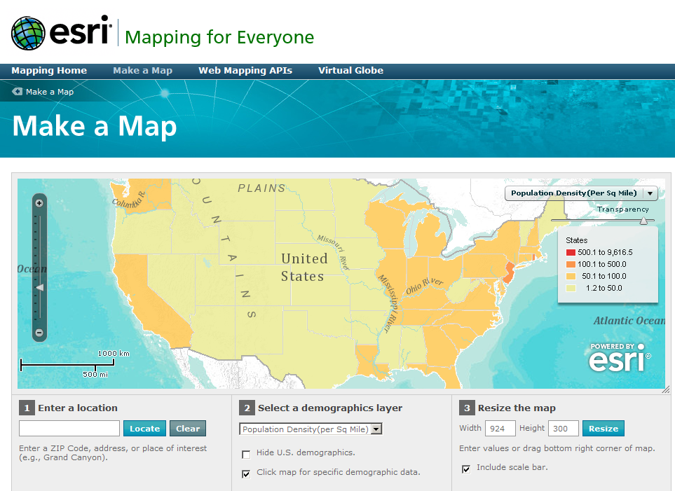
How can differences in neighborhoods be analyzed and measured? Median age, home value, population change, and household size are just a few variables that can be useful in analyzing how your neighborhood differs from others in your community or across the country. Maps are a powerful way to detect patterns and uncover cause-and-effect relationships. “Mapping Your State and Community” poses questions that help you think spatially at scales from local to state to national.

Background: A Geographic Information System (GIS) is a combination of computerized maps, databases containing information about the data on those maps, and procedures that people use to make everyday decisions that involve the “where” question—where habitats are most threatened, where earthquakes pose the greatest threat, where greenways can be best planned alongside rivers in cities, where a business can be most favorably located, where crop rotation and contour plowing can help prevent soil erosion and degradation, and other decisions in government, higher education, industry, and nonprofit organizations. To use a GIS most effectively takes a spatial perspective— considering those patterns, relationships, and trends that are not easily evident in tables or graphs, but those that stand out on maps—and using that perspective to better understand our world and to make the best decisions possible. In any mapping application, the amount of detail shown, i.e., scale, matters. Variables change based on the scale, from a coarse, small scale (at the United States level), to fine, large scale (at the city or neighborhood level).

Introduction: Note: This example is designed for use with material on the Mapping For Everyone web site. Should you be unable to access this site, it is still possible to do the main activities by following the fully worked-out activities for Lawrence, Kansas, which begins on page 4.

Additional resources are listed at the end of the exampleUse the videos and information on http://edcommunity.esri.com, particularly the Geography Awareness Week, Earth Science Week, and the School Superintendents’ “Syfr” page, as well as the resources on http://www.gisday.com, to introduce the concept of GIS. Two growing trends are to place GIS on mobile devices (GPS receivers, handheld computers, cell phones, in cars), and to place GIS on the Web. The Mapping For Everyone site used in this activity is an example of a simple to use but powerful Web GIS to help understand population characteristics.

Because not all classes have online access, this activity can be done in several ways. Where class time and facilities allow, students can do this individually or in small groups as a directed laboratory exercise. If there is a single online computer visible to all students, the activities can be done by the class as a whole. Where there is no in-class internet access, the instructor can generate the materials in advance, and progressively show the results to the class as the lesson unfolds.

Because Mapping For Everyone uses information from the US Census Bureau, start with http://www.census.gov/aboutus/, discussing what a census is, why it is taken, and how its data can be used. What are the benefits and limitations of the data from a self-reported national census? What segments of the population would be more likely to be undercounted? Why?

Activity 1: Explore Variables by State: Visit http://www.esri.com/mappingforeveryone and select “make a map” under the small map on the page. You should now be at the “Make a Map” site. Select the “Make a Demographic map” link, and your map will look similar to the map on Page 1. What do the colors mean on the map? How does population density differ from total population? How is population density calculated?

Click on individual states to see the exact population density. Which state has the highest population density? Which state has the lowest? Name three factors that influence population density. Are the factors that you named economic, political, physical, or something else? How does the size of the state influence population density?

Fill in the following table. How can you determine the size of each state given total population and population density?

State | Total Population | Population Density | Size (Square Miles)
New Jersey
Colorado
<Pick A State>

Activity 2: Explore Variables by County: Use the slider bar on the left, or double-click on the mouse, or hold down the shift key while dragging a rectangle on the map, to zoom in on a state with a high population density. Start with New Jersey. As you zoom in, you will see population density by county instead of by state. What difference does scale make to your understanding of population density? Which parts of New Jersey have the highest population density? Which parts have the lowest? Examine the cities in New Jersey. What influence do cities have on population density? Why? Repeat this process for your own state and summarize in a short paragraph what you learned about population density in your state.

Activity 3: Examine Population Change: Zoom back out to the United States and change the variable to population change, 2000-2009. Describe the pattern that you see of the fast-growth states versus the slow-growth states. How many years does this time period encompass? If a state had 0.5% growth during each of those years, how much growth would it have over the period? What color would it be symbolized as? Name three factors that influence why people move, and hence, why population changes. What do you predict the fastest growing states in 2010-2020 will be, and why? Zoom to your own community. Fill in the 2-word phrase that defines the level of geography that lies between county and block group.

Coarse ← Scale → Fine
State County ________________ ________________ Block Group

In your opinion, which level of geography is most similar to the concept of “neighborhood?” Identify some block groups in your community. What is the mean population of these block groups? Show your work here:

What parts of your community are growing the fastest? The slowest? Why? Name three factors that influence the growth rate of different parts of a community.

Activity 4: Examine Median Age: Describe what a “median” is in mathematics. How is median age of the population calculated? Zoom back out to the United States and change the variable to Median Age. What regions of the United States have the youngest median age? The oldest? What factors influence whether a region will have a young or old median age? What do you predict the median age of a college town will be? Zoom to the following communities and record the median age of 5 census tracts, as in the model.

Community | 5 Census Tract Numbers (last 3 digits) | Median Age in those 5 Census Tracts | Mean Age of 5 Census Tracts
Lawrence, KS | 502, 300, 400, 901, 501 | 23.7, 22.9, 20.4, 25.9, 27.7 | (23.7+22.9+20.4+25.9+27.7)/ 5 = 24.12
Laramie, WY
Sun City, AZ
<Your Community>

Can you find a census tract where the median age is younger than 21? What kinds of communities would you say Lawrence Kansas and Sun City Arizona are based on the median age of the census tracts there? What implications does the median age have in terms of planning a community—such as schools versus nursing homes, or skateboard parks vs. golf courses?

Activity 5: Putting It All Together. Group project: Say that the City Council for your community has asked your class to put together a presentation describing what your community is like based on the demographic characteristics that you have analyzed. Break apart into small groups. Each group decides what variable to examine and will have 5 minutes to present to the Council. Make sure that each group will analyze a different variable. Come back together as a class and rehearse all of the presentations. Choose a spokesperson to introduce the groups, and another person to offer concluding comments. Include maps as part of each presentation and analysis. If you are using the Mapping For Everyone Web GIS tool, you can link to your maps, save them as graphics, and even embed them in your own web page. How do the variables that you studied change based on the scale? Based on your analysis, include in your presentation what you think your community will be like in 20 years. Select at least one other community in the United States that you are interested in (such as one you used to live in, or one you have visited) and compare that community to your own community. How is your community like or different from the other community you have selected? How have dynamic maps that you created yourself using the Mapping For Everyone Web GIS tool helped your understanding of your community? How are these maps different from printed maps?

Example: Analyzing Lawrence, Kansas. I am interested in investigating Lawrence, Kansas, and so I type in Lawrence, KS in the box under [1] “Enter a Location.” The default theme is population density per square mile. I see that Lawrence’s Census Tracts have a density of over 1,000 people per square mile, higher than the surrounding area, which makes sense given that it is a community surrounded by a rural area. If I zoom out a bit, I see that Lawrence is midway between the higher density communities of Topeka to the west and Kansas City to the east. It contains about 14 census tracts, as opposed to about 20 for Topeka and about 100 for Kansas City, and therefore I would say that Lawrence is smaller in population.

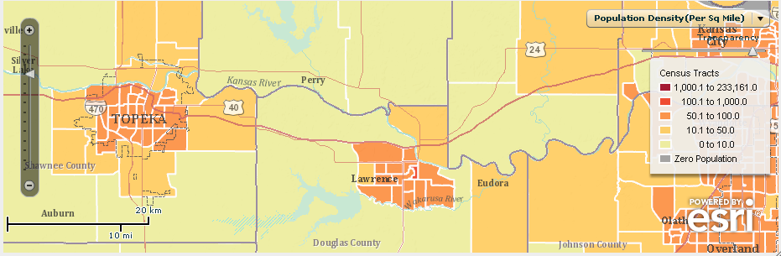

If I zoom to the county level and select counties, Lawrence’s Douglas County has about 114,000 people, while 176,000 people live in Shawnee County, which contains Topeka. This confirmed my population hypothesis.

However, the raw numbers only tell a part of the story, so I change the theme to population change and zoom out until I can see Kansas and Missouri. Even though the USA increased from 281 to 308 million people from 2000 to early 2010 (as verified on the Census Bureau’s population clock), not all areas experienced population growth. Indeed, I see that western Kansas and northern Missouri counties are declining in population.
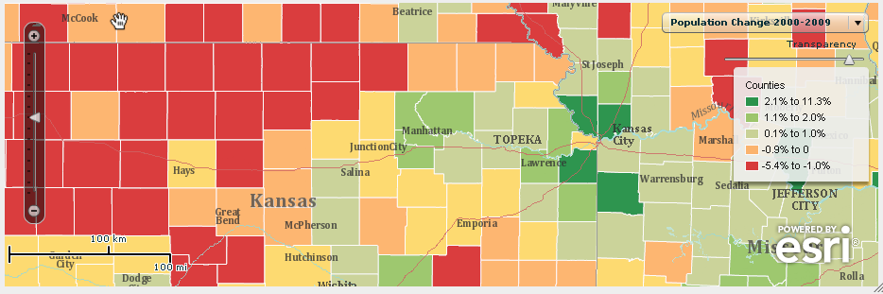

After further outside research, I discover that the major reason for the declines in these areas is the rural-to-urban migration that began a century ago with the consolidation of family farms into larger farms run as an“agribusiness”, and better job opportunities in urban areas. But other reasons exist: Junction City in Riley County, Kansas is experiencing a decline in population because it is dominated by a large US Army base, which is reducing its staff. And some neighborhoods in central Kansas City, Missouri are decreasing because of urban-to-suburban migration.

Back in Lawrence, I change the variable to median home value. After seeing how the value ranges from $75,000 on the east side of town to over $250,000 on the west, and discovering that the unemployment rate is also higher on the east side, I conclude that the west side is more affluent. A quick tour down some of the streets in Google Street View confirms my conclusion visually. The variable that sets Lawrence apart from the surrounding region is its median age:
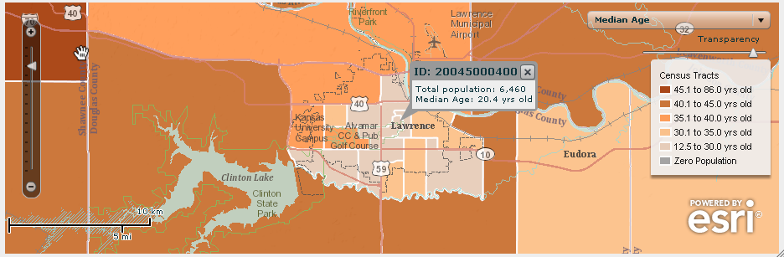

After averaging the median age for a selection of 5 Census Tracts (502, 300, 400, 901, and 501), I am left with a value of (23.7+22.9+20.4+25.9+27.7)/ 5 = 24.12 years. Outside research confirms that Lawrence is the home of a large state university, the University of Kansas. I discover that this university was founded in 1866 and has grown to over 30,000 students today. This number is larger than one neighborhood, and the neighborhoods with a low median age must include the dormitories and the bulk of the student housing on and near campus. Zooming in, I see the labels for the student union and stadium which confirms my hypothesis. Changing the variable to average household size indicates that the lowest values are in the same neighborhoods as the low median age, which again makes sense given the fact that most college students live alone or with very few roommates.
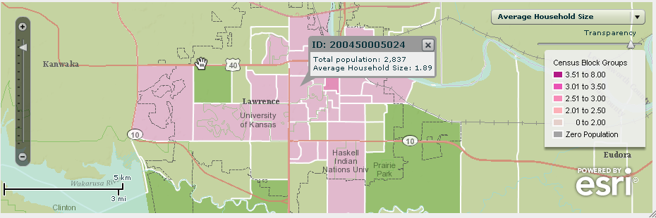

My maps have become an investigative tool in my overall research to help me understand the community. I can use the same procedures to investigate a different community, compare the data to that for Lawrence, and most importantly, investigate the reasons why those differences exist, and where they exist.

Extensions. Examine the variables using the Mapping For Everyone resource that you may not have yet studied, such as median household income, median home value, unemployment rate, and average household size. How do these variables influence each other? How do they change based on the scale of analysis? How do they change over time? Use other Web GIS tools from the list below to conduct additional research.

Additional Resources:

Web GIS:
ArcGIS Online: http://www.arcgis.com
National Atlas: http://nationalatlas.gov
This Dynamic Planet: http://mineralsciences.si.edu/tdpmap/
Pacific Disaster Center: http://www.pdc.org/atlas/html/atlas-viewer.jsp
Graduation Rates Map: http://www.edweek.org/apps/maps/
Planetary GIS: http://webgis.wr.usgs.gov/pigwad/maps/index.html
GIS in Education:
ESRI Education Community: http://edcommunity.esri.com
Learning To Think Spatially: http://www.nap.edu/catalog.php?record_id=11019
Community Atlas Program: http://edcommunity.esri.com/communityatlas

Conferences and Organizations
ESRI Education User Conference: http://www.esri.com/educ
Association of American Geographers: http://www.aag.org
Geospatial Information Technology Association: http://www.gita.org
National Council for Geographic Education: http://www.ncge.org

References: GIS in Education
Alibrandi, M. 2003. GIS in the Classroom: Using Geographic Information Systems in Social Studies and Environmental Science. Portsmouth, NH: Heinemann.
Golledge, R., Marsh, M., and Battersby, S. 2008. A conceptual framework for facilitating geospatial thinking. Annals of the Association of American Geographers 98(2): 285-308.
Kerski, J. 2008. The World at the Student’s Fingertips: Internet-based GIS education opportunities. In Milson, A., and Alibrandi, M. (Eds.) Digital Geography. Information Age, pp. 119-134.
Kerski, J. 2009. The implementation and effectiveness of GIS technology and methods in secondary education. Germany: Verlag.
Malone, L., Palmer, A., and Voigt, C. 2002. Mapping Our World: GIS Lessons for Educators. Redlands, CA: ESRI Press.
National Academy of Sciences. 2006. Learning to Think Spatially—GIS as a Support System in the K-12 Curriculum. Wash DC: National Academies Press, 313 p.
Orton Family Foundation. 2003. Making Community Connections: The Orton Family Foundation Community Mapping Program. Redlands, CA: ESRI Press.
Phoenix, M. 2004. Global GIS Education. Geomatics Information Magazine, pp 34-37.
Schultz, R.B., Kerski, J., and Patterson, T. 2008. The use of virtual globes as a spatial teaching tool with suggestions for metadata standards. Journal of Geography 107(1): pp. 27-34.
Zanelli-English, K., and Feaster, L. 2003. Community Geography: GIS in Action. Redlands, CA: ESRI Press.
◆

