Document ID: 03_13_07_1
Date Received: 2007-03-13 Date Revised: 2007-07-24 Date Accepted: 2007-11-13
Curriculum Topic Benchmarks: S14.3.2, S14.3.4, S15.3.5, S12.3.6, S12.3.8, S12.4.6, S12.4.7
Grade Level: Middle School [6-8], High School [9-12]
Subject Keywords: rotation, Earth rotation, pendulum, Foucault, Newton’s laws
Rating:

Earth Turns? Prove It!

By: Stephen J Edberg, Jet Propulsion Laboratory, California Institute of Technology, 4800 Oak Grove Drive, M/S 301-486, Pasadena CA 91011
e-mail: Stephen.J.Edberg@jpl.nasa.gov

From: The PUMAS Collection http://pumas.jpl.nasa.gov
©2007, Jet Propulsion Laboratory, California Institute of Technology. ALL RIGHTS RESERVED.

We are all told that the Earth turns and we accept that. But an actual demonstration of how scientists proved this can have lasting impact on the acceptance of this authoritative statement and also on how students judge other authoritative statements for themselves, scientific or otherwise. Satisfying oneself that Earth does actually rotate shows what can be done to encourage such thinking.

With the acceptance of Copernicus’ model of a Sun-centered universe (solar system) by the 1600s, it was agreed that Earth revolves around the Sun and with it that Earth rotates. The two ideas go together naturally (in a philosophical sense) but actual proof of Earth's rotation, relying on measuring effects here on Earth, was not demonstrated until the 1800s. (Earth’s orbital revolution around the Sun was proved by the late 1830s, though there was a missed opportunity for proving it in the early 1700s.) In 1851 Jean Bernard Leon Foucault (pronounced Foo-KOH; 1819-1868) hung a pendulum in the Pantheon in Paris and showed Parisians that the apparent motion of the plane (in which the pendulum bob swung) was in fact due to Earth’s rotation. In other words, the pendulum was swinging in a fixed plane with respect to background stars as Earth turned beneath it, carrying the Pantheon and everything else around.

This demonstration uses a pendulum at the north “pole” of a small scale “Earth” to show the fixed swing-plane and the “planet” rotating beneath it. Students can then apply their classroom observations to a gedanken (thought) experiment at Earth’s North Pole or South Pole.

OBJECTIVE: Understand how a pendulum demonstrates that Earth really rotates.

APPARATUS:

- Tripod Any camera tripod whose legs can be extended to a height of one yard or higher will do the job. Cost will be a few tens of dollars from a camera store or discount department store. The tripod doesn’t need to be fancy or especially sturdy – it only has to stand on its legs and it won’t be supporting much weight.
- Swiveling desk chair Find a desk chair that turns smoothly on its own swivel bearing. Rough turning interferes with the demonstration.
- Monofilament fishing line Small diameter (low pound test) line is more desirable but not required. Thick weed trimmer monofilament is not suitable. A few meters of fishing line will last a lifetime of demonstrations. Cost is a few dollars from sporting goods or discount department stores but a fisher-friend will probably give you a suitable length.
- Pendulum bob Use a fishing weight (less than a dollar from sporting goods stores) or a large heavy washer or nut (each less than a dollar) or a plumb bob (a few dollars) from a hardware store, to attach to the monofilament. A heavier bob with a cylindrical (axis parallel to the monofilament) or spherical shape will suffer less air resistance.

PROCEDURE:

Construct a pendulum that will hang over the rotation axis of the swivel chair. Assemble the apparatus in advance of the demonstration.

- Extend the tripod so it stands three to five feet in height. A higher tripod providing a longer pendulum may be more fun to watch, as long as it can be stably placed on the chair seat. Rubber leg tips will help the tripod stay in place on the chair and protect the seat from damage. The legs can be taped or lashed down if necessary for stability.
- Attach the bob to the monofilament. If it is a fishing weight, simply attach the weight to one end if it has rubber grips for the line. If the weight has a loop or is a washer or nut, start by tying a loop in the monofilament: fold over about two inches of the monofilament at one end and tie a simple overhand knot, making a small loop in the end. Pull the knot tight. Thread the monofilament loop through the hole in the bob and thread the other end of the monofilament through loop, trapping the bob in a slip knot.
- Determine the length of the desired pendulum and cut off any extra monofilament (allowing some extra for a knot and loop on the suspension end). If necessary, make another loop (large enough for the bob to fit through) in the other end of the monofilament and attach that end of the monofilament to the tripod. The attachment point does not have to be exactly centered under the tripod head but it should be close. The swinging monofilament and pendulum bob should not collide with any tripod or chair parts.
- Place the assembled pendulum (tripod + hanging bob) on top of the swivel chair seat. (Fig. 1) Adjust the leg positions and lengths to place the pendulum pivot directly over the chair’s swivel. The pivot point should also be close to the geometric center of the tripod assembly. This improves overall balance and stability and reduces the chance of the tripod tipping over. Confirm that the pendulum bob won’t hit the tripod legs or chair. Start the bob swinging along any direction, although one parallel to a wall of the classroom helps observers maintain a reference direction to better see that the plane within which the bob swings stays fixed. Standing in one place (and reaching around as necessary), slowly rotate the chair in either direction. You and the students will observe that even as the chair is rotating, the swing-plane of the pendulum maintains a (nearly-)fixed direction.

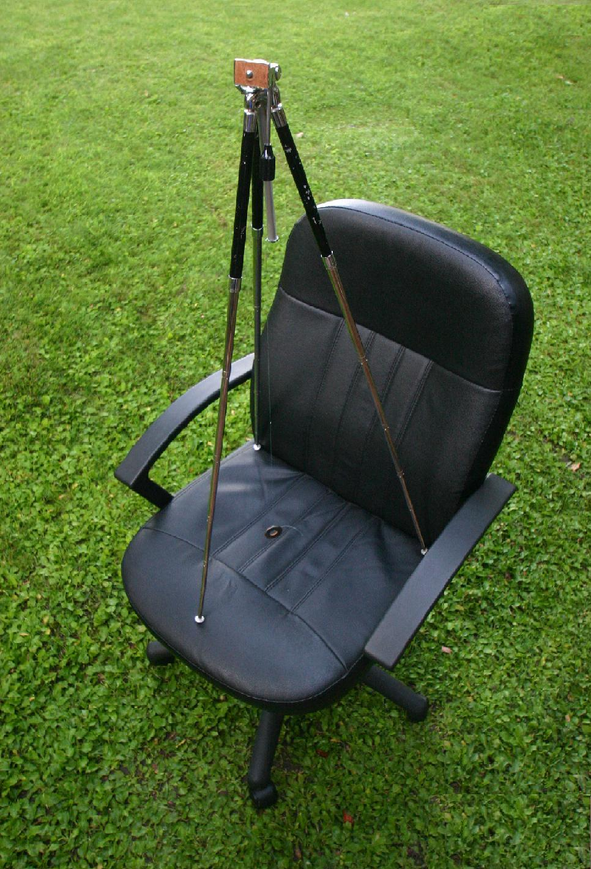

Figure 1. A rickety old tripod is entirely adequate for this demonstration. The pendulum bob, a large washer, hangs from the bottom of center post.
- Explain to the students that they should make a mental trip to the North (or South) Pole of Earth. If they were to build a pendulum there, the situation would be the same: the Earth (chair) is turning under the pendulum. In 24 hours Earth would make a full rotation under the pendulum. In a few tens of seconds the chair rotates under the pendulum.

THE UNDERLYING PRINCIPLES:

Newton’s first law of motion is exhibited by the pendulum, albeit with the effects of the second law and his law of gravitation. The first law says that an object in motion (or stationary) remains in motion (or stationary) unless acted upon by an outside force. The force of gravity causes acceleration that stops the pendulum bob at its maximum amplitude and reverses its direction. But the force of gravity acts only down, not crossways, so there is no sideways force that moves the pendulum’s swing-plane. In the room, the plane does not change with respect to the walls. At the North or South pole, the plane does not change with respect to the stars. Since the plane is not changing, it must be the platform – chair or Earth – that is rotating underneath the pendulum.

DISCUSSION:

This demonstration is being done in the real world and there are additional effects on the pendulum. An asymmetrical bob will be affected by the air it swings through. Instead of the bob maintaining its own orientation with respect to the swing-plane, as required by Newton’s first law, small aerodynamic effects may cause it to spin or simply orient itself to minimize air friction (like the direction arrow on a weather vane).

While the bob is being affected by the air flow, it is also being affected indirectly by the (chair’s) rotation. Because the tripod is turning with the chair, the monofilament connecting the bob to its pivot at the top of the tripod is turning with it. This occurs because the monofilament is subjected to a rotational force (it is being torqued) by the turning tripod. The monofilament will attempt to minimize this by “unwinding”. This unwinding will rotate the bob.

The combination of air flow and torque can slightly affect the orientation of the swing plane.

EXTENSION:

How, your students may (will, we hope) wonder, does this work at locations other than the North or South Pole, i.e., at latitudes less than 90 degrees? The answer is that at all latitudes there is a vector component to the rotation of Earth. It has maximum magnitude at the poles and is zero at the equator (Fig. 2).
Φ
Φ
Z
ZsinΦ

Figure 2. Earth’s rotation vector at the North Pole is illustrated by the dashed line at the top, arbitrary magnitude Z. At latitude Φ, the dashed rotation vector is shorter, with magnitude = ZsinΦ. At the equator, Φ = 0 and sinΦ = 0 so, with no component of Earth’s rotation there, the Earth does not rotate beneath the pendulum. At the North pole the latitude = 90 degrees and sin(90) = 1 so Earth rotates beneath the pendulum at one revolution per day.

The apparent rotation of the swing plane at latitude Φ can be considered from two perspectives:

- How long does the swing plane take to return to its starting position at some latitude?
The answer is given by the simple equation

  - H [hours] = 24/(sinΦ)

At the North and South Poles, Φ = 90°. Since sin(90) = 1, the plane’s rotation period is 24 hours. (Strictly speaking, the latitude of the South Pole is -90° and sin(-90) = -1. The minus sign manifests itself as plane rotation in the opposite direction from the rotation at the North Pole.) At the equator, Φ = 0°. Since sin(0) = 0, the plane’s rotation period is 24/0 = ∞ (undefined) hours. We interpret this to mean that the plane is not apparently rotating.

- How many degrees does the swing plane rotate in one day?
The answer is given by the simple equation

(2) D = 360° sinΦ

Again, at the North and South Poles, Φ = 90°. Since sin(90) = 1, the plane’s rotation angle is 360°. (Strictly speaking, the latitude of the South Pole is -90° and sin(-90) = -1. The minus sign manifests itself as plane rotation in the opposite direction from the rotation at the North Pole but in the same amount of time.) At the equator, Φ = 0°. Since sin(0) = 0, the plane’s rotation angle is 360° x 0 = 0°. The plane is not apparently rotating.

From the naïve perspective of an observer on Earth’s surface, the rotation of the pendulum bob’s plane is due to the Coriolis effect. This effect is nicely illustrated with an animation at http://en.wikipedia.org/wiki/Coriolis_force .

FOR MORE INFORMATION: The California Academy of Sciences website http://www.calacademy.org/products/pendulum/index.html has a good, comic-style discussion of Earth’s rotation as proven by a pendulum.

An animation of the plane rotating with respect to Earth at 30 deg. latitude can be found at http://en.wikipedia.org/wiki/Foucault_pendulum .

ACKNOWLEDGMENT:

I am grateful to the guides at Griffith Observatory, Los Angeles, for their demonstration of this phenomenon when I was a young student. Obviously, it had a large impact.

This publication was prepared by the Jet Propulsion Laboratory, California Institute of Technology, under a contract with the National Aeronautics and Space Administration.

Reference herein to any specific commercial product, process, or service by trade name, trademark, manufacturer, or otherwise, does not constitute or imply its endorsement by the United States Government or the Jet Propulsion Laboratory, California Institute of Technology.

