Document ID: 04_28_05_1
Date Received: 04-28-05 Date Revised: 08-19-05 Date Accepted: 08-25-05
Curriculum Topic Benchmarks: M3.3.9, M3.3.11, M3.3.17, M3.4.3, M4.3.3, M4.3.7, M4.4.4, M4.4.6, S15.3.2, S15.3.3, S15.4.4
Grade Level: [9-12] High School
Subject Keywords: star distances, parallax, trigonometry, geometry, triangle, distance, angle, small angle approximation, estimation
Rating: Advanced
When a Ruler Is Too Short

By: Stephen J Edberg, Jet Propulsion Laboratory, California Institute of Technology, 4800 Oak Grove Drive, M/S 301-486, Pasadena CA 91011
e-mail: Stephen.J.Edberg@jpl.nasa.gov

From: The PUMAS Collection http://pumas.jpl.nasa.gov
©2005, Jet Propulsion Laboratory, California Institute of Technology. ALL RIGHTS RESERVED.

Surveyors are often seen in the middle of the street making careful measurements of angles with their transits, and distances with their steel tapes. For points than can be easily reached, such a survey is convenient. But when the target is inaccessible – a mountain summit or a distant star – known distances can be combined with measured angles to determine a distance or altitude. The method relies on parallax, the way an object appears to move, relative to a more distant background, when viewed from different angles. In 1838, Friedrich Wilhelm Bessel became the first to successfully apply this method to a star, measuring an angle of <0.5 second of arc for the summer star 61 Cygni. (One second of arc is the angle you get when you divide one degree into 3600 equal parts. For comparison, the Moon’s diameter as seen from Earth is about 0.5 degree, or 1800 arcsec.) A new NASA mission, SIM PlanetQuest, applying the same technique to determine stellar distances, will measure angles to an accuracy of one microsecond (one millionth of a second) of arc!

This activity lets students measure distances in the classroom using parallax. The exercise can be done either at a high school level using trigonometric functions, or at a middle school level using simple arithmetic approximations to the trigonometric functions. A work sheet is provided for the middle-school-level activity.

OBJECTIVE: Measure the length of one’s arm using parallax. This demonstrates a technique that is sometimes the only option for measuring distances to truly remote objects. For the exercise, the student’s finger represents the target star, and lines on a wall chart serve as background “stars” against which the parallax is measured.

APPARATUS: (1) Wall chart marked with parallel, vertical lines. The chart can be laid down on a chalkboard or white board, or if you plan to use this lesson repeatedly, the chart can be drawn on butcher paper and reused. The chart should span the width of the classroom, so each student can view normal (perpendicular) to some part of the chart. Otherwise perspective will throw off the desired measurements. Use a yardstick to draw vertical lines a convenient distant apart, between 5 and 10 cm (2 and 4 inches). The spacing must be regular and its exact value needs to be known. Consecutively number each line at its top.
In advance of this activity, the distance from the chart to each row of student seats in the room should be measured with a tape measure. Calculate the scale factor (angular spacing) of the lines as viewed from each row using the equation:

scale factor = arctan $\frac{{\text{line}}_{\text{spacing}}}{{\text{viewing}}_{\text{dis}}\text{tan}{\text{ce}}_{{\text{from}}_{\text{chart}}}}$ or
scale factor = arctan $\frac{R}{D}$ as illustrated below.
(Note: the operation arctan = tan⁻¹.)

Wall Chart
R
D
scale factor

Make sure to use the same units for line spacing and viewing distance. These scale factors will be given to the students for their computations.

- Tape measure. Having several available to the students is desirable. Some furniture store chains have paper tapes free for customer use and may be willing to donate some.

- Millimeter ruler. One per pair of students is recommended. Some furniture store chains have paper tapes free for customer use and may be willing to donate some (which could be cut down 15 cm lengths, if desired).

PROCEDURE: The specifics for the students are provided on the worksheet below. This middle school-level worksheet can be modified to be suitable for the students’ knowledge of mathematics.

Students are instructed to make a measurement of the angle subtended by an extended finger held at arm’s length. Each student should fully extend one arm, aimed toward the wall chart with parallel, vertical lines. They should extend their “pointer” fingers up, towards the ceiling. Instruct the students to blink their eyes alternately, one open while the other is shut. They should note how their fingers change position against the background (look at the numbers at the tops of the lines to make a comparison).

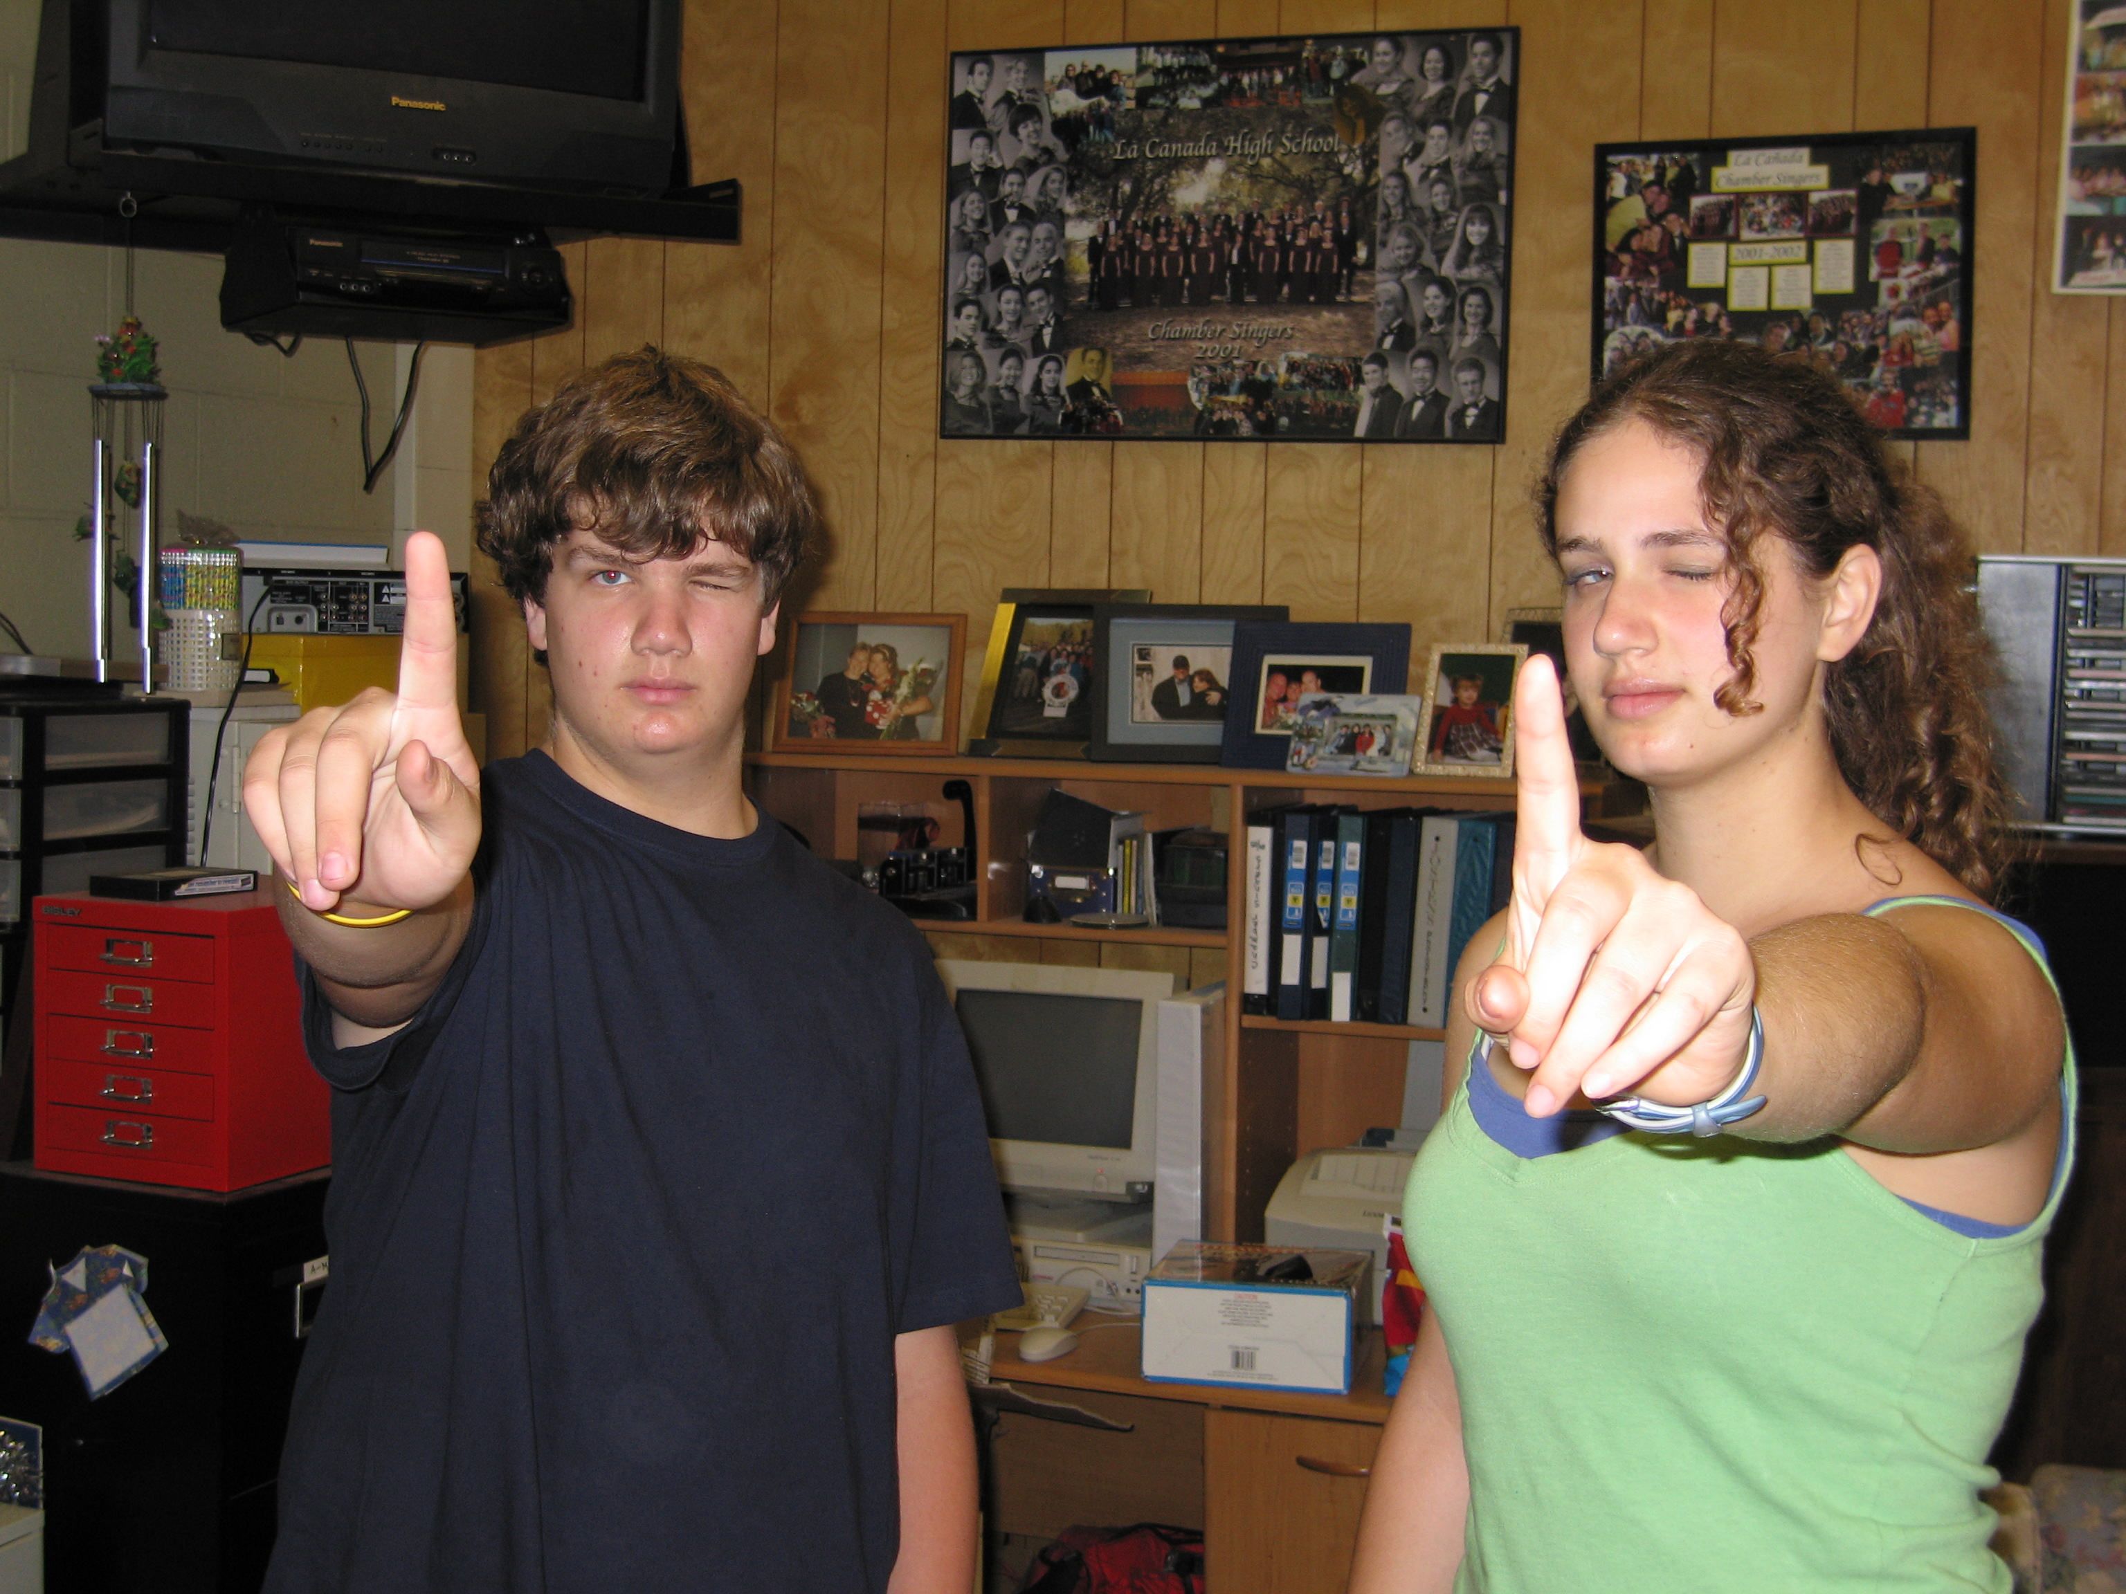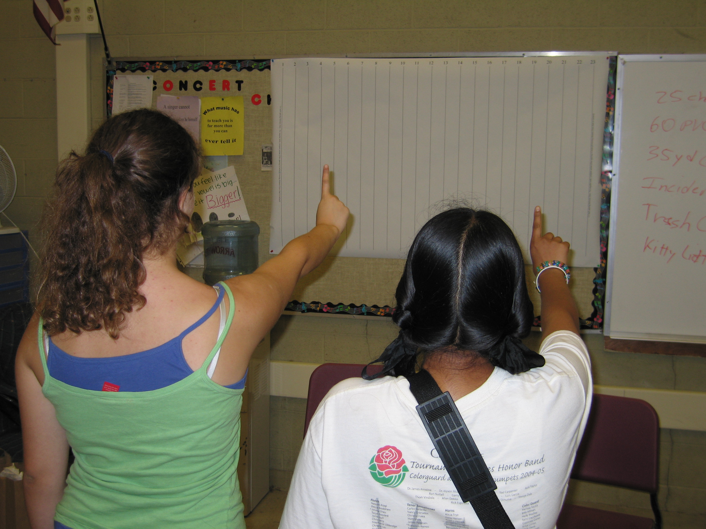

For the measurements, the students close one eye and align the side of the extended finger with a line on the chart, directly in front of them (they should be looking directly perpendicular to the wall). After recording the line number they switch open and closed eyes and make note of the new position.

The number of lines + fractional distance separating their finger positions is the desired angular (after conversion) measurement. The students’ arms must be held in a fixed position for the estimates. (Some students may prefer to keep both eyes open and focus on the lined background while estimating the spacing of the two foreground images of their fingers. This requires concentration but is, perhaps, less fraught with error.)

The lined background provides known angular separations between the lines. In the sky, stars are randomly placed and at a variety of distances, so we use much more distant stars, having no detectable parallax, to measure the parallax of closer stars. The regular spacing of the lines on the classroom background is for measuring and computational convenience.

Students have to count the separation between the two apparent positions of their fingers, including an estimate of any fraction of a spacing between lines. It is best to pick one side of the finger to align with a background line with one eye then estimate the separation to the same side of the finger with the other eye.

Students working in pairs should measure the separations of each others eyes. A short ruler is convenient for this, with the ruler held on the nose or forehead while the interpupilary distance is measured. Pupil center-to-center or edge-to-corresponding-edge should be measured as accurately as possible and with high precision. Care will be necessary for a good measurement. Using their measurements and the scale factor (angular spacing of background lines from their seat row, in degrees) supplied by you, the students then do the algebra/geometry or trigonometry necessary to calculate the lengths of their arms.

The students finish by comparing the length calculated with a measurement made with a tape measure. Now they run into the problem of repeatability when holding their fingers and arms in the same positions as for their parallax measurements. They also have to estimate the correct measurement end points for their eyes: is it their corneas, retinas (how deep do their eyes go behind their corneas?), or somewhere in between? This lack of certainty of the position of one endpoint and the repeatability of arm+finger extension can be used to introduce the concepts of uncertainty and error margin in a final result.
R
D
parallax angle δ

THE UNDERLYING PRINCIPLE: The basic geometry of this lesson is illustrated above. We wish to calculate the distance D based on our knowledge of the length R and the measured parallax angle δ. Note that the students are measuring (2 x δ) and (2 x R) since their observations use both eyes. The factor of 2 has to be removed during their calculations. To make this calculation there are two options; the selection is based on the mathematical sophistication of the students.

1) From trigonometry we know that $\text{tan}δ=\frac{R}{D}$ (1)
which can be rewritten $D=\frac{R}{\text{tan}δ}$ (2),
the solution we seek.
2) Up to 9 or 10 degrees, an angle [measured in radians] ≈ sin (angle) ≈ tan (angle). This means that for the small angles measuring fingers, and even smaller angles measuring stars, we can take advantage of this “small angle” approximation. Conversion of the measured parallax angle δ to radians is easy: δ [rad] = (δ [deg]/360) x 2π ≈ tan δ, to be used in equation (2).

Note that equation (1), rewritten to δ = arctan (R/D) = tan⁻¹(R/D) is used to compute the scale factor, where R is the separation of the lines on the background chart and D is the distance to each row of seats in your classroom.

DISCUSSION: Parallax measurements provided astronomers with their first distances to the stars and, along with stellar aberration, a physical proof of the Copernican theory of the solar system. Parallax measurements form the basis of the cosmic distance scale and are still used to refine it. The European Space Agency’s Hipparcos mission provided an enormous catalog of space-acquired stellar parallaxes. NASA’s SIM PlanetQuest will refine some of those measurements by a factor of 300 to 1000, making it possible to discover planets orbiting other stars and to determine their masses and orbital characteristics, among many other astrophysical measurements of interest.

It is interesting to plot student height vs. arm length: the result should be a straight line, with some scatter, proving that humans are built with the same proportions. Expect a
wider spread with adolescents since their growth comes at different times for different parts of their anatomy. The plot demonstrates techniques used for anthropological studies of humans for which fossil evidence rarely includes a complete skeleton.

FOR MORE INFORMATION: http://planetquest.jpl.nasa.gov/SIM/sim_index.html
Visit this website for more information on the SIM PlanetQuest mission. Websites discussing the Hipparcos mission, its namesake Hipparchus, stellar parallax, and proper motion will also be interesting.

ACKNOWLEDGMENT: This publication was prepared by the Jet Propulsion Laboratory, California Institute of Technology, under a contract with the National Aeronautics and Space Administration.
Distant background of stars (in reality not all at the same distance)
Finger at arm’s length
Not to scale.
Finger Parallax Geometry
Closer star
2 x δ
Left—Eye—Right
Lined background
Earth’s Orbit
Not to scale.
Parallax Angle δ
Stellar Parallax Geometry
Parallax Angle δ

Student Worksheet
In this measurement experiment, we will use parallax, a measurement of an angle, to measure the length of your arm. Since we can, we will check your parallax result with a tape measure. Astronomers don’t have this luxury when measuring the distances to stars.

1. Fully extend one of your arms, aimed toward the wall chart with parallel, vertical lines.

2. Extend your “pointer” finger up, towards the ceiling. Blink your eyes alternately, one open while the other is shut. Note how your finger changes position relative to the background (look at the numbers at the tops of the lines to make a comparison).

3. With one eye closed, align one side of your finger with a line on the chart, directly in front of you (you should be looking directly perpendicular to the wall). Write down the line number here:
__________
4. After recording the line number, close the same eye and return your finger to the position just noted and hold it there.

5. Switch your open and closed eyes, without moving your extended finger. Note the number of the uncovered line nearest to the side of your finger that you started with. Write down the line number here:
__________
The chart lines you used are simplified representatives of very distant stars (!), while your finger is like a nearby star. In the sky, measurements would be made with respect to background stars, which would be selected all around the star of interest. The numbers on the chart are representative of angular measurements made with a telescope, but, obviously, are not labeled on the real sky.
Now we have to compute the parallax angle. To figure out the parallax angle and distance we need to measure one distance.

6. Use the millimeter ruler provided. Have your partner measure the separation of the pupils (the black centers) of your eyes. Write the separation here:
_______ mm.

7. to calculate the angle separation of where your finger appeared for each eye, first subtract the number from Step 5 from the number in Step 3. If the difference is negative, take the absolute value (or subtract the number in Step 3 from the number in Step 5).

Step 3 ______ or Step 5 ______

Step 5 -______ or Step 3 -______

Difference = ______ Difference = ______ (should be a positive number)

Because each observer is sitting at a different distance from the “background stars” on the chart, a correction has to be made for the distance from the chart. We don’t, and can’t, do this in the real sky.

8. Fill in the Scale Factor (in degrees) given to you by your teacher below. It is different for each row of seats. Multiply your scale factor by the difference computed in Step 7 to determine the angle, which is twice the parallax angle:

[Difference (Step 7)] x [Scale Factor] = [Double Parallax Angle]

_______ x ______ = _____________

9. Divide the Double Parallax Angle by two to determine the Parallax Angle.

$\frac{{\text{Double}}_{{\text{Parallax}}_{\text{Angle}}}\text{,_}{\text{Step}}_{8}}{2}={\text{Parallax}}_{\text{Angle}}$

Parallax Angle = $\frac{}{2}$ = _________ degrees

10. If you have a scientific calculator it’s easy to do the actual trigonometry (“tan” stands for the mathematical operation of computing the tangent). If you don’t have one, skip to step 11.

Finger-to-Eye Distance = $\frac{0\text{.}5{\text{xEye}}_{\text{Separation}}\text{,_}{\text{Step}}_{6}}{\text{tan}({\text{Parallax}}_{\text{Angle}}\text{,_}\text{Step}9)}$

= ________ mm
Skip to step 12.

11. If you don’t have a scientific calculator, you can use the small angle approximation. Because the angles involved are small (less than 10 degrees out of 360 degrees in a circle), we can simplify the trigonometry this way, though there is a little more arithmetic. The parallax angle (in degrees) has to be converted to units called radians. This is done with this expression, where π = 3.1416:

$\frac{2πx({\text{Parallax}}_{\text{Angle}}\text{,_}{\text{Step}}_{9}}{\text{360}}$= Parallax Angle in radians

2 x 3.1416 x $\frac{}{\text{360}}$ = ________ radian

Then the Finger-to-Eye Distance = $\frac{0\text{.}5x[{\text{Eye}}_{\text{Separation}}\text{,_}{\text{Step}}_{6}]}{{\text{Parallax}}_{{\text{Angle}}_{{\text{in}}_{\text{Radians}}}}}$

= 0.5 x __________/___________ = ________ mm

12. Divide your Finger-to-Eye Distance (Step 10) by 25.4 to get the length in inches:

= ___________ mm/(25.4 mm/inch) = ________ inches

13. With help from your partner, measure the distance from your eye to your fingertip. Be careful not to get poked!
Measured Length _________ inches

14. Think about why the values from Step 11 and Step 12 are different. Where are there experimental errors?

