Document ID: 06_12_06_1
Date Received: 2006-06-12 Date Revised: 2006-07-14 Date Accepted: 2006-07-14
Curriculum Topic Benchmarks: M3.2.10, M3.3.10, M3.3.11
Grade Level: [3-5] Upper Elementary
Subject Keywords: Dollars, Cents, Shopping, Coupons, Pricing, Units
Rating: Easy
Coupon Math:
Dollar$ or Cent$?

By: Jackie Vogel, Austin Peay State University, PO Box 4626, Clarksville, TN 37122 email: vogelj@apsu.edu

From: The PUMAS Collection http://pumas.jpl.nasa.gov
© 2006, California Institute of Technology.
Privacy Statement ALL RIGHTS RESERVED. Based on U.S. Gov't sponsored research.

Problem: It is common in the real world to see mathematical examples where the cents sign was used when the dollar sign was supposed to be used. Converting and comparing decimals and fractions can help clear up this misconception. Two real coupons clipped from the Sunday paper coupon section are included in this activity.

Discussion:
1. An example frequently seen by students involves 0.99¢ burger specials on local marquees. Can you really buy a burger for $\frac{\text{99}}{\text{100}}$¢? What does that mean?
Fill in the blanks.
$\frac{\text{99}}{\text{100}}$ of a whole dollar = $ _____ = _____ ¢

2. 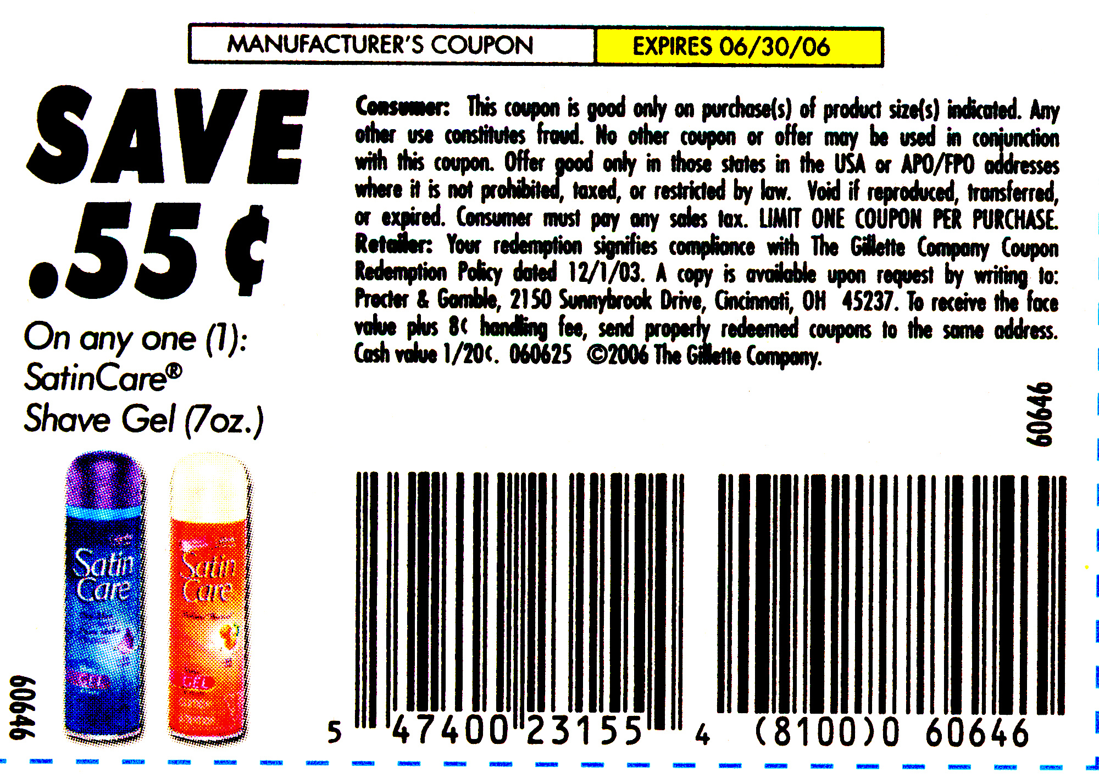

What is wrong with this coupon? What corrections would you make to this coupon?

Fill in the blanks.
$ 0.55 = ______ ¢ = $\frac{}{\text{100}}$ of a whole dollar

3. 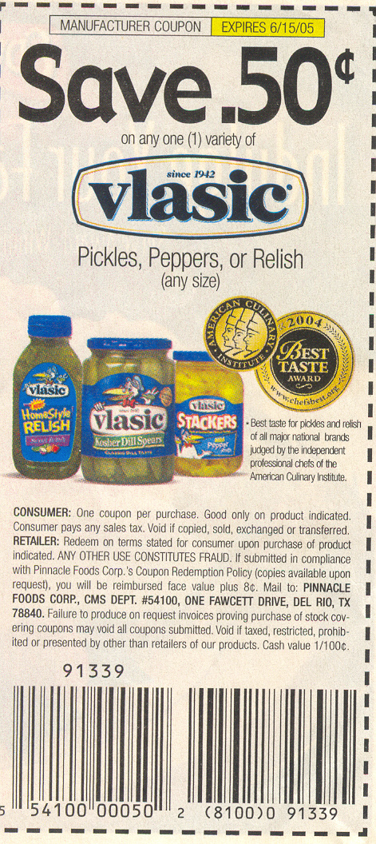
What is wrong with this coupon? What corrections would you make to this coupon? If your local grocery store doubles coupons, what would be your discount for this coupon?

4. Can you find another example of the misuse of the cents versus dollar sign in the real world? (There are many of them out there!)

