What Makes Cities Hot? An Urban Heat Island Activity
Anna Scott
Overview
The source of heat on Earth is the Sun. Sunlight passes through the air, warms the surface, and then radiates into the air as heat. How warm the surface becomes depends on the material that the surface is made of-–this is why standing in a parking lot is uncomfortable in the summertime but walking on the grass in a park is tolerable. This is also why cities and urbanized areas are generally hotter than rural areas, a phenomenon that scientists call the urban heat island. We can explore these ideas by testing the temperatures of different locations and materials outdoors (or indoors, substituting a lamp with a tungsten bulb for the sun) using thermometers.

Objective: Students will understand that heat is transmitted from the sun, the difference between surface and air temperature and the relationship between surface and building materials and temperature.

Materials: You will need thermometers (consider paper thermometers available at brewing stores) and a variety of solid materials: aluminum foil, sand, black construction paper, white construction paper, soil, and two green sponges (sod or potted wheatgrass or grass would be a great substitute if available). Optional: heat sensitive paper or liquid crystal paper. Additionally, students should have pencils and paper, and the teacher should have a blackboard/whiteboard or notepad or large piece of paper to compute results. If there isn’t enough sun outside, then substitute a lamp with a heat bulb or any non-led and non-fluorescent bulb.

Setup
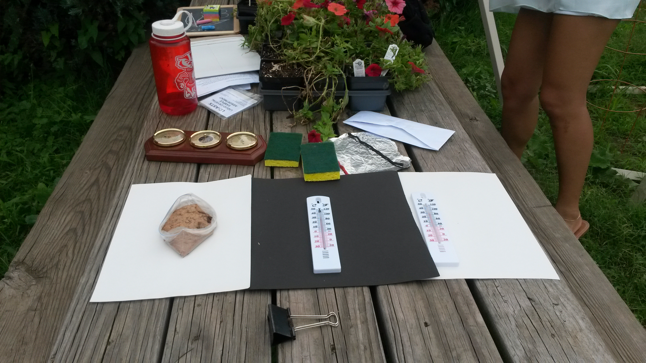
Figure 1: Sample setup.
Lay out the different materials in the light. Slightly moisten one of the sponges. Place thermometers on top of and touching each material, as well as a thermometer above the material that is reading air temperature.

Activity
Show the students the setup, explain how to read a thermometer, and ask them to read off the temperatures. Demonstrate the difference between the temperature taken in the air, and the temperature taken of a hot object. See if they are getting similar measurements, and if not, discuss. If thermometers have Fahrenheit and Celsius scales, ask them to read off both and translate between each one.
Once students are familiar with the thermometers, ask them to identify the hottest and coolest objects. After a brief discussion (see Discussion section), give the students thermometers, and a pencil and paper. Ask students to record the hottest and coolest air temperatures around the site. Also ask them to find the hottest and coolest materials around the site, record their temperatures, and mark down where they were and if these areas correspond.
Students should notice that sunny areas are hot, concrete is hot, brick is hot, grass is cool and that walls facing south are hotter.

Note: this activity works particularly well if the site includes a concrete sidewalk as well as vegetation and walls or any variety of land covers and materials, so students may focus on measuring the different objects available. If not, then focus may be directed to how much sunlight each area received: walls on the south side of buildings are generally warmer because they receive more sun, whereas the north side of buildings are generally shaded and receive less sunlight.

Substitutions for older/more advanced students:
While students are measuring temperature, draw a map that roughly illustrates the ground (demarcating grass and asphalt or other land cover classes) and a table to record their results. Compute statistics as appropriate for the student’s level (mean, range, max, min, etc.) and make a map marking land temperatures in one color and air temperatures in another color.

Substitutions for younger/less advanced students:
Ask students to touch the various materials and ask which is hotter. Explain how to use a thermometer to measure this, and ask them to find which is hotter. Discuss.
Take the heat sensitive or liquid crystal paper. Explain how the color changes when exposed to heat. Take the sponges, and ask which they think is hotter and cooler. To test this, wipe the moist sponge on the heat sensitive or liquid crystal paper, or use a spray bottle for droplets. Instantly, the color should change. Explain how when we sweat, we cool off by evaporation, and so similarly the paper is cooling off and reacting to the change.

Discussion, or, what are we seeing, and why?
1) Differences between the ground and the air:
The black piece of paper is warmer than the air above it. This is because the paper is a solid and opaque to sunlight, and the air is a gas that is transparent to sunlight. Gases have molecules that are farther apart than those of solids, meaning that gases generally hold less heat and so are cooler than solids. While not all gases are transparent to sunlight (for example, air containing the pollutant gas NO₂ is brownish), and not all solids are opaque (consider clear plastic or glass), when light passes through our air it doesn’t interact with the molecules, leaving its energy to be passed to the Earth’s surface.

2) Differences between temperatures of materials:
The different materials have different reflective properties and thus different absorption properties, which is why the paper’s color makes a difference: white paper reflects the sunlight better than the black paper. Energy is conserved, so the more energy a material reflects, the less that it is able to absorb and re-emit as heat. The materials also absorb heat differently due to their conductivity, which is why denser materials like metal are hotter than paper (metal has a higher conductivity than paper).
Water can also play a role in this: when water heats up, it evaporates. Evaporation requires a lot of energy, and when the water goes from liquid to gas form it absorbs energy.

3) Differences between site locations:
Different site locations receive different amounts of sunlight. In particular, south facing walls receive more sunlight, turn more energy into heat, and are thus warmer.

5) How does this affect our city?
Parks and green spaces cool the city. Trees that offer shade can reduce the amount of sunlight that reaches the ground and will reduce the air temperature below. Building out of materials that reflect light rather than absorb it can help lower temperatures as well; one example is painting roofs white.

