Document ID: 10_04_04_1
Date Received: 2004-10-04 Date Revised: 2004-11-16 Date Accepted: 2004-11-23
Curriculum Topic Benchmarks: M1.3.5, M3.3.17, M5.3.3, M9.3.2, S12.3.7, S18.3.2
Grade Level: [9-12] High School
Subject Keywords: volcanoes, urban planning, debris flows, cross-section, slope, contours, topographic map
Rating: Moderate

Volcanoes and Urban Planning

By: Lucas Moxey, National Oceanic and Atmospheric Administration (NOAA), CoastWatch – Central Pacific Node, 2570 Dole Street, Honolulu, HI 96822. e-mail: Lucas.Moxey@noaa.gov

From: The PUMAS Collection http://pumas.jpl.nasa.gov
© 2004, California Institute of Technology. ALL RIGHTS RESERVED. Based on U.S. Gov't sponsored research.

Introduction
The numerous annual volcanic eruptions that occur worldwide evidence the potential dangers they often create. Volcanoes are found across a wide variety of geologic settings, including subduction zones (i.e.: Andes, Cascades, Aleutian Islands) and hotspot settings (i.e.: Hawaii-Emperor Seamounts, Galapagos, Azores). Regardless of their location, history has demonstrated that volcanoes pose a vivid and real hazard to regional settlements and environments. The eruption of Mt. St. Helens (Washington – 1980), Nevado del Ruiz (Colombia – 1985), Mt. Hudson (Chile – 1991), Mt. Pinatubo (Indonesia – 1991) and Reventador (Ecuador – 2002) are just some of the numerous examples in which volcanic eruptions affect large regions.

During an eruptive episode, it is common for a volcano to emit varying amounts of gases (sulfur dioxide, carbon dioxide and water vapor), lava, and/or ash, in addition to releasing considerable amounts of seismic energy (earthquakes). Often, these combine to form debris flows (also called “lahars”), which are water-saturated flows of volcanic debris that travel down steep topographic gradients at high speeds. While following steep slopes, their fluid component allows them to travel over large distances (over 300 kilometers) with a thickness of up to 200 meters. Lahars typically form in volcanoes that contain large amounts of snow, or that contain large glaciers. When an eruption occurs, the high temperatures partially melt the existing snow and glaciers. The availability of liquid water and volcanic debris induces their mixing, giving rise to large debris flows.

Figure 1 shows a 3-dimensional perspective of Volcan Villarrica, located in central Chile. The volcano is located deep within the South American Andes, and as such, it has had a rich history of explosive eruptions. More recently, since 1971, Villarrica has had numerous eruptions that released large amounts of ash and lava, in addition to creating devastating lahars. Figure 1 consists of a high-resolution satellite image that shows the steep topography of the glacial-covered volcano, as well as a snow-free lava lake summit. Red and green-gray colors represent areas of vegetation and Villarrica’s lahars, respectively. The towns of Pucon and Villarrica provide a representative view of their proximity to the volcano’s lahars.

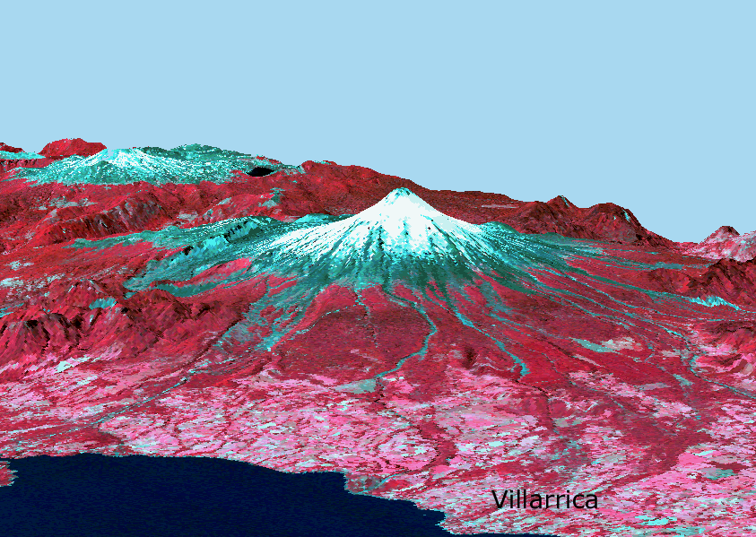
Figure 1. 3D view of Volcan Villarrica (Chile) showing the extent of the volcanic debris flow. A snow-free summit can be observed atop the volcano due to the presence of an active lava lake. The scene combines a high resolution false color satellite image and detailed topographic data.

CLASS ACTIVITY

Objective
To use high-resolution satellite data for selecting a new and safer location for the town of Villarrica, along with its corresponding communication and evacuation routes.

Materials
- Satellite image showing Villarrica’s current volcanic hazards (Figure 2)
- High resolution topographic map (Figure 3)

Background & Methods
Based on the findings from a new survey conducted by city management officials, volcanologists have discovered that the current location of the town Villarrica is very vulnerable to future lahars from the volcano (see Figures 1, 2 and 3). In view of this, city officials and emergency managers resolved to move the city to a safer location. For this, they have selected your team of city planners and volcanologists, to choose the new location for the town of Villarrica, along with its new and improved communication and evacuation routes.

NOTE TO EDUCATORS: Detailed information regarding the construction of topographic cross-sections, slope analyses, and interpreting topographic maps is readily available from the PUMAS examples “Cross section and Slope” and “Contouring and Topo Maps.”

To achieve this objective, your team should be able to answer the following questions:
- Where did the previous lahars originate, and which route did they follow?
- Why did they follow those paths? How do they relate to the slope of the terrain?
- Prepare a cross-section extending from the town of Villarrica, through the summit and into the opposite side of the volcano. What is the overall topography?
- Propose three locations for the new town, and prepare a topographic cross-section for each. Analyze the three profiles and list their advantages and disadvantages (i.e.: proximity to the volcano’s summit, average slope, existence of natural barriers, etc.)
- Consider the paths for the new communication/evacuation routes. Remember that these should follow areas of low gradients, preferably far away from the volcano.
- After deciding on the safest location, plot the new town site and proposed roads on the topographic map provided.
- Contact your city’s urban planning coordinators and share your findings; can you guess what would be the cost for moving the town of Villarrica to your new location?

Conclusions
- Prepare a short presentation to explain and discuss the proposed location of the new town and the paths for the communication/evacuation routes.
- What do urban planners generally consider while dealing with natural threats? Can you think of some factors that they would consider under a flooding river scenario? What about earthquakes?
- Can you think of any types of barriers that could be emplaced along the volcano’s flanks for preventing lava flows and/or lahars from reaching the town? What would these diverting structures look like, and where would you put them?
- Why is it important for people from different fields (i.e.: volcanologists, urban planners, engineers, etc.) to work together for achieving a common goal?

Acknowledgements
Satellite data collected by the ASTER sensor onboard the NASA Terra satellite. Data courtesy of NASA/GSFC. Topography data obtained from the NASA Shuttle Radar Topography Mission (SRTM). 3D composite and satellite data processing by Lucas Moxey (NOAA). The author gratefully acknowledges Sun He Bak (NOAA) and two anonymous reviewers for an exceedingly thorough review of the manuscript.

Figure 2. Satellite image of Villarrica Volcano. Note the volcanic debris flows (green-gray colors) reaching the proximities of the town Villarrica (NW of the volcano).

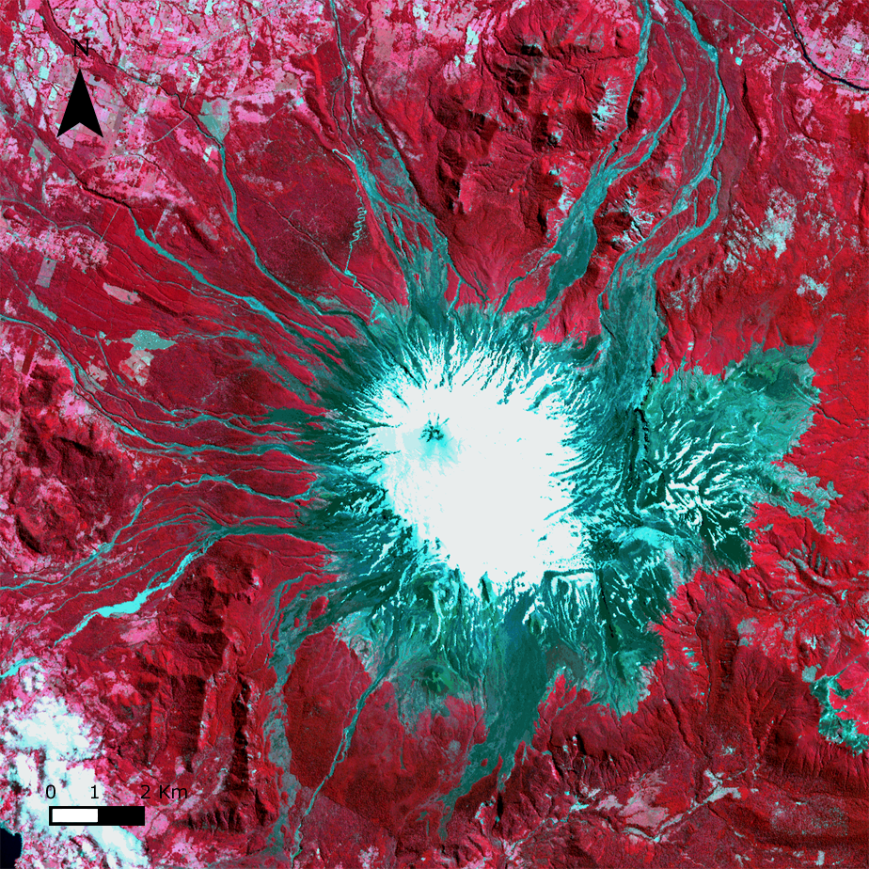

Villarrica

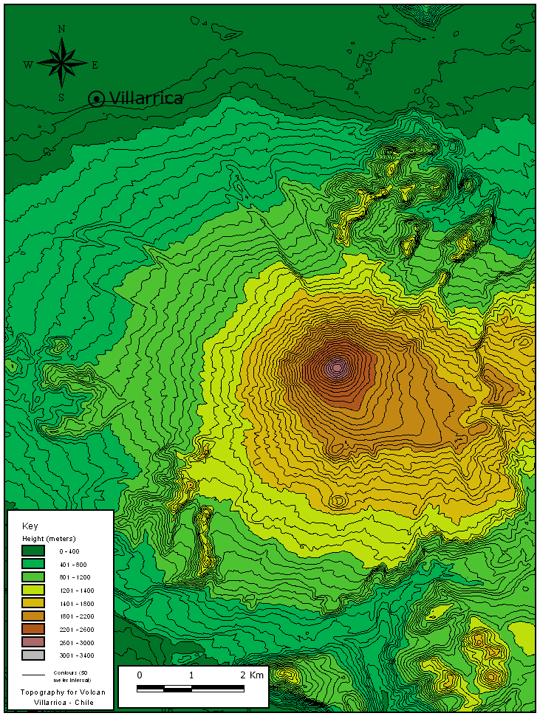
Figure 3. Topographic map for the Volcan Villarrica region.

