Document Id: 12_30_02_1

Date Received: 2002-12-30 Date Revised: 2003-01-16 Date Accepted: 2003-01-21

Curriculum Topic Benchmarks: M6.4.7, M9.4.4, M6.3.1, M9.3.1
Grade Level: High School [9-12]
Subject Keywords: Logarithms, Mean Value, Statistics, Non-linear
Rating: moderate

Logarithms: Taking the Curve Out

By: Lin Chambers, NASA Langley Research Center, MS 420, Hampton, VA 23681-2199
e-mail: L.H.Chambers@larc.nasa.gov

From: The PUMAS Collection http://pumas.jpl.nasa.gov
© 2002, California Institute of Technology. ALL RIGHTS RESERVED. Based on U.S. Gov't sponsored research.

Logarithms are very handy when dealing with numbers at lots of different scales (see related PUMAS example: Just What is a Logarithm, Anyway?). But they also have another useful feature: they help us average measurements of physical phenomena that have nonlinear behavior. A common example in my field of study relates cloud “albedo” to cloud optical depth (Fig. 1); but similar examples may be found when examining many natural phenomena.

Some definitions:
Albedo is the fraction of light hitting an object that is reflected back. It ranges from 0 (all light hitting the object is absorbed) to 1 (all light hitting the object is reflected).
Cloud Optical depth is a measure of how much the cloud keeps light from penetrating through it. A cloud with optical depth less than 1 is transparent, that is, you can see through it. The lower the optical depth, the more transparent the cloud. A typical cumulus cloud (those puffy clouds that look like interesting shapes in the sky) may have an optical depth around 40; a towering thunderstorm can have optical depth well over 100 (that’s why it’s so dark under a storm).

The curve in Figure 1 shows a sample of nonlinear behavior: when the optical depth (x) is small, then the albedo (y) increases proportionally to (linearly with) the increase in optical depth. But when the cloud gets to a higher optical depth, say above 10, then the albedo increases more slowly. This is typical of a saturation process, or what we might call “diminishing returns.”

Measurements of this kind are taken routinely using satellite remote sensing, as cloud properties affect both weather and climate. In order to assess cloud effects at different scales, averaging of the properties must be done. This leads to some mathematical issues.
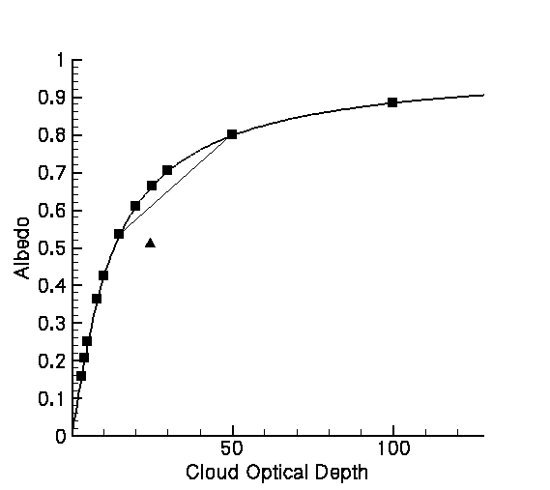

Figure 1. Albedo versus cloud optical depth, a nonlinear phenomenon.

Curves with this kind of shape are called convex curves, and they have an interesting property: if you take the average of any two points on the curve, the resulting mean value will be below the curve. For example, look at the line drawn above between two points on the curve. The mean value of those two points is halfway along this line, and not very near the curve itself. Thus if you have variable clouds – and you always do – the average albedo computed from a number of measurements will always be lower than the curve, or less than the true value. For example, if the squares on the curve above represent measurements you have made then the triangle shows the value you would get from a linear average. This average is not a good approximation for the actual behavior represented by the curve.

Here are the numbers corresponding to the black squares, so you can do the averages yourself:
x | y
3 | 0.1580700
4 | 0.2053100
5 | 0.2496000
8 | 0.3630800
10 | 0.4235400
15 | 0.5349700
20 | 0.6096500
25 | 0.6631200
30 | 0.7039300
50 | 0.7987000
100 | 0.8850200
Ave x: | Ave y :

Now let’s take a look at what happens if we take the same curve, and plot it using a logarithmic axis for the x-axis (Fig. 2).
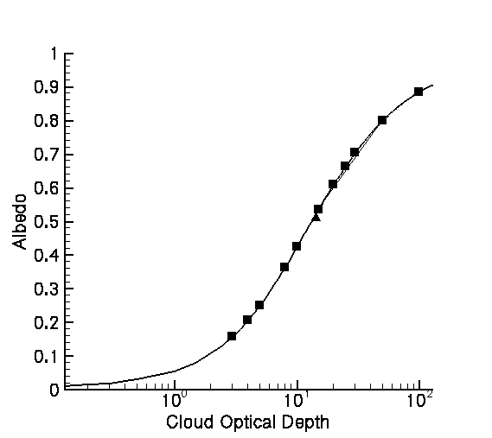

Figure 2. Albedo versus cloud optical depth, with logarithmic x-axis

Comparing this graph to the previous one, you will see that we get a much straighter line, particularly in the part of the curve where our measurements (the black squares) are located. The result is an average value (the black triangle), which is much closer to the curve than before. Thus, transforming the x-axis to a logarithmic form is a mathematical way to obtain a better value for the average cloud properties over a region that includes clouds of varying moderate optical depth. It would not be necessary for very thin clouds, where the behavior is already linear.

Extension: The same idea can be used with other mathematical functions to take out other types of curvature that may exist in measurements of natural processes. This approach might be driven by theory, which suggests that a process follows a particular type of curve; or it might be done by trial and error application of some standard transformations, such as the logarithmic transformation shown here.

